Gameplay Abilities

Gameplay Abilities are actions or skills that an actor can perform

* Class derived from UGameplayAbility
* Defines what an ability does and the conditions under which it can be used
* Not implemented as a simple function; GAS game ability is an instanced object running asynchronously
* Can be activated at some point in time and run multi-stage tasks that may or may not span across a span of time
* These tasks could branch off into different tasks, apply their own gameplay effects, kick off **gameplay cues**
* Can be conditional, based on player or environmental interaction
* Gameplay abilities have built-in replication and prediction support
* Built in concept of cost and cooldown

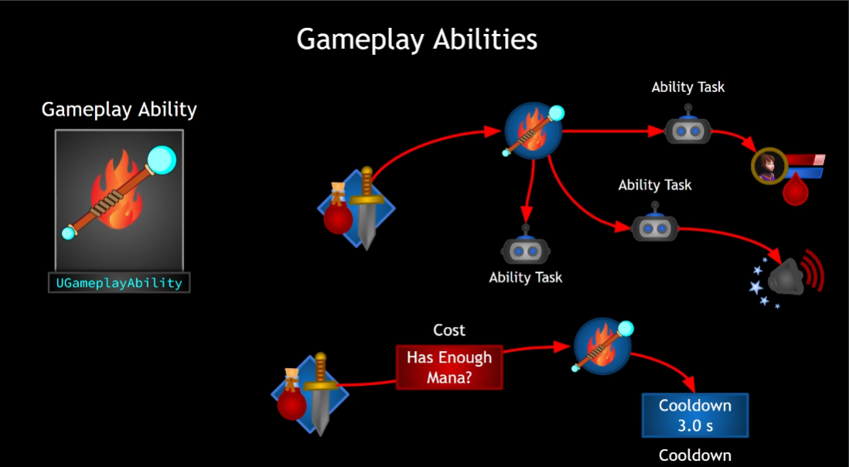

## Ability Tasks

Gameplay abilities use ability tasks (although they don’t HAVE to)

* Ability tasks derived from UABILITYTASK
* Specialised form of UABILITYTASK
* Perform asynchronous work during a gameplay ability’s execution
* Can affect execution flow by broadcasting delegates
* Can be used in C++ or in BP through a specialised BP node
* BP node can have multiple output execution pins
* These are execute as a result of delegate broadcasts made in response to occurrences determined by developer – thing happens in game, task broadcasts delegate
* Can design the ability in the BP but make the actual work happen in code, very flexible

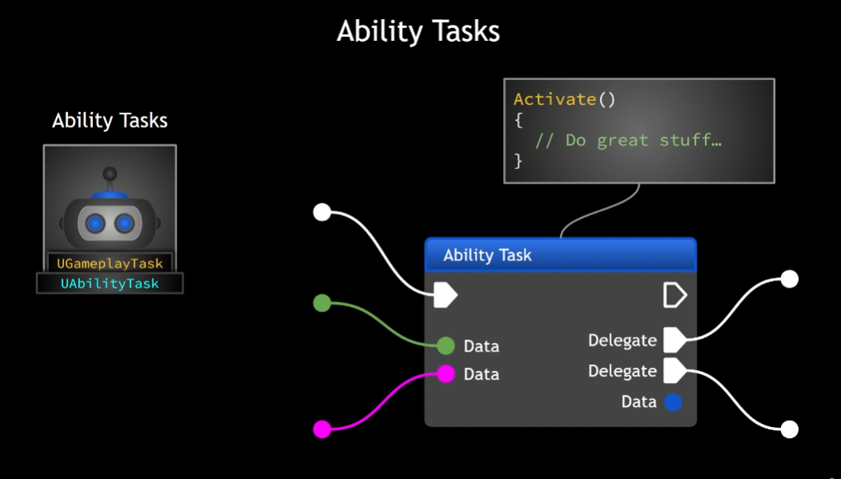

## Granting Abilities

To use a gameplay ability the ASC must be *granted* the ability

* GameplayAbilitySpec is created
* Spec defined details pertaining to that ability including
* GameplayAbility class itself
* Ability level
* Dynamic info that can be changed at run time
* Abilities granted on the server
* Ability spec then replicates to the owning client

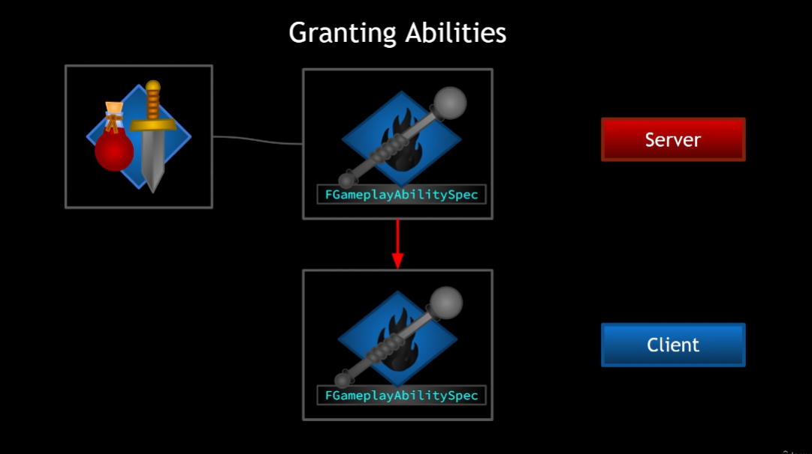

Gameplay Abilities have the concept of *Activation*

* Once activated, gameplay abilities are *Active*
* Until Ended or Cancelled
* Abilities can end themselves or be cancelled exernally

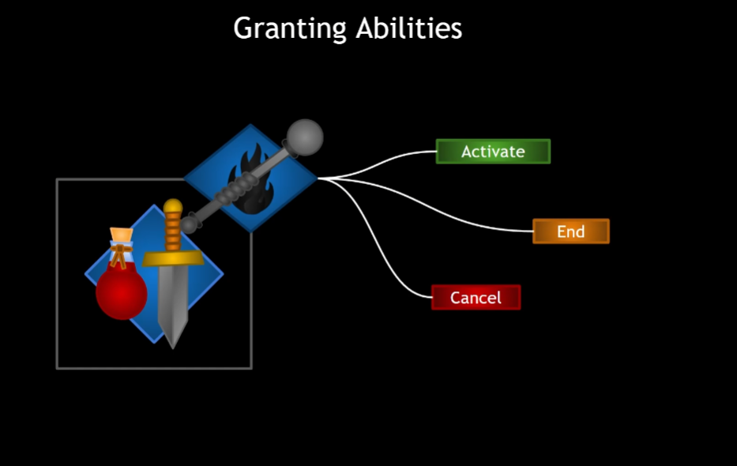

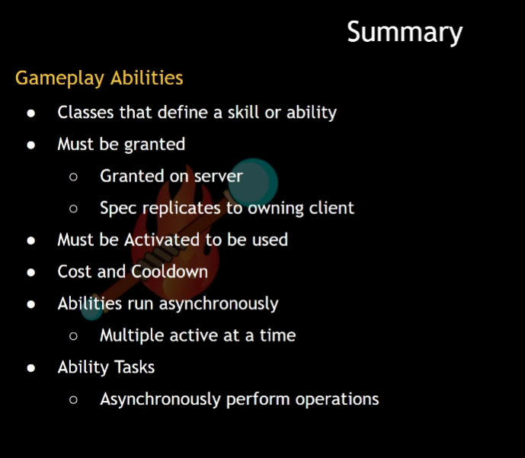

# Granting Abilities

Possible: Make a blueprint based on the gameplay ability class

Instead: create a base class of our own! That way all GPA we create will have the option to have some baseline functionality

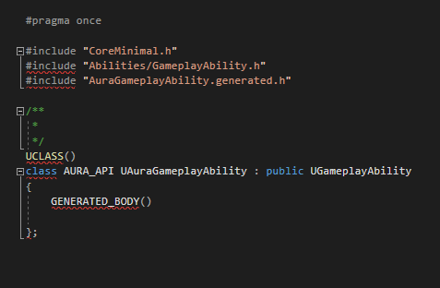

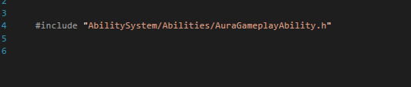

Very basic template to start!

So, we want to grant abilities and this is done on the server

Let’s start by just giving the character a list of abilities that should be given at the start of the game

In AuraCharacterBase:

Add a TArray of GameplayAbility classes(type TSubclassOf)

Then we can set that TArray from within the character blueprint

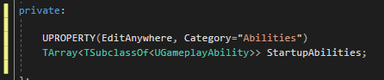

So there will be an array of abilities, Now we need a way to *give* these abilities

This is done through the AbilitySystemComponent, so let’s add a function for adding those abilities

We may want to override in child classes so Protected

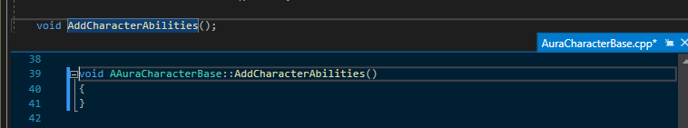

This function should only add abilities on the server, so we’ll do an auth check first

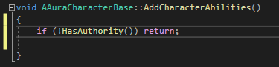

If we do have authority we want to:

Grant the ability; done by ASC, so let’s have the ASC actually do it; the CharacterBase will just call it

It should be public

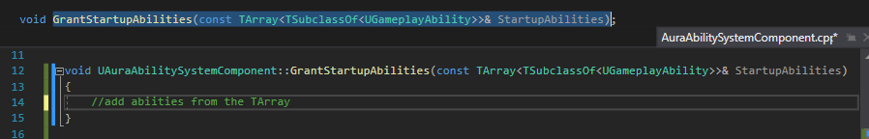

The function will need to take in Gameplay Ability classes – this is the function we’ll call from CharacterBase

Since it’s a list of things we’ll loop through them

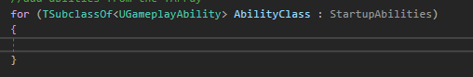

To add the abilities we need to create an ability spec from each of the ability classes

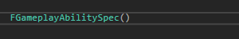

This is a struct that requires an ability class, so we’ll pass in AbilityClass

It also requires an ability level

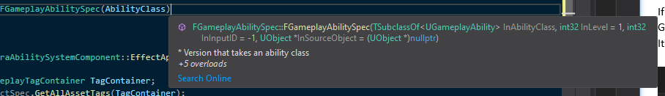

Levels are just int32s. We’ll store the struct locally



And now we have the Spec, we can just use a function that exists on the ASC already called GiveAbility()

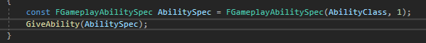

We could also give the ability and activate it immediately!

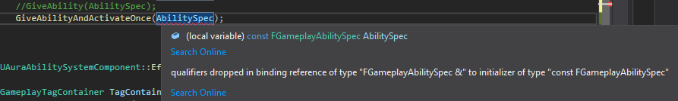

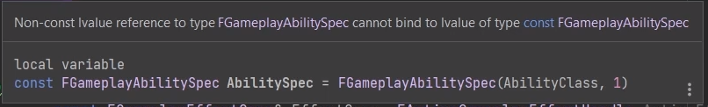

AbiltySpec *cannot* be const if we’re going to GiveAbilityAndActivateOnce!

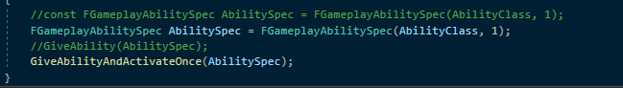

GiveAbility will accept either

For the moment we’re gong to use ActivateOnce, because as a learning exercise I want to see what happens when an ability is activated and this is the easiest option that I know so far

Last thing to do here is call the function in AuraCharacterBase

To do this we’ll need to cast to the ASC

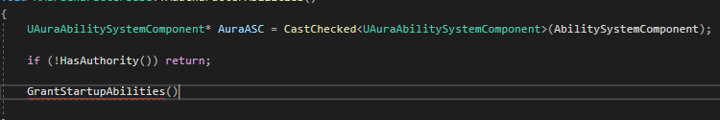

Nb this requires an include for the AuraASC.h

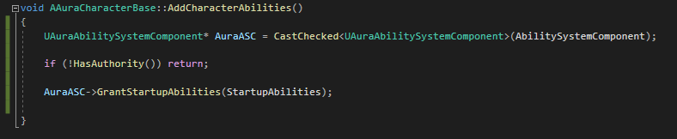

So, where to call AddCharacterAbilities?

For the player character, a good place is in PossessedBy (worry about enemy later)

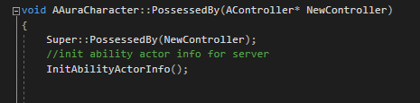

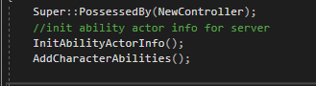

Now we should see the ability added after InitAbilityActorInfo

We should expect, upon calling this function, to be granted all the abilities in the startup ability array

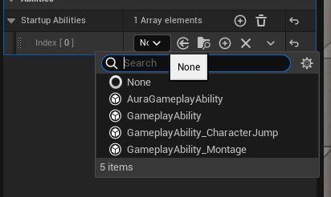

We can set the array of abilities here and there are some defaults, but I will make a new BP for the Abilities

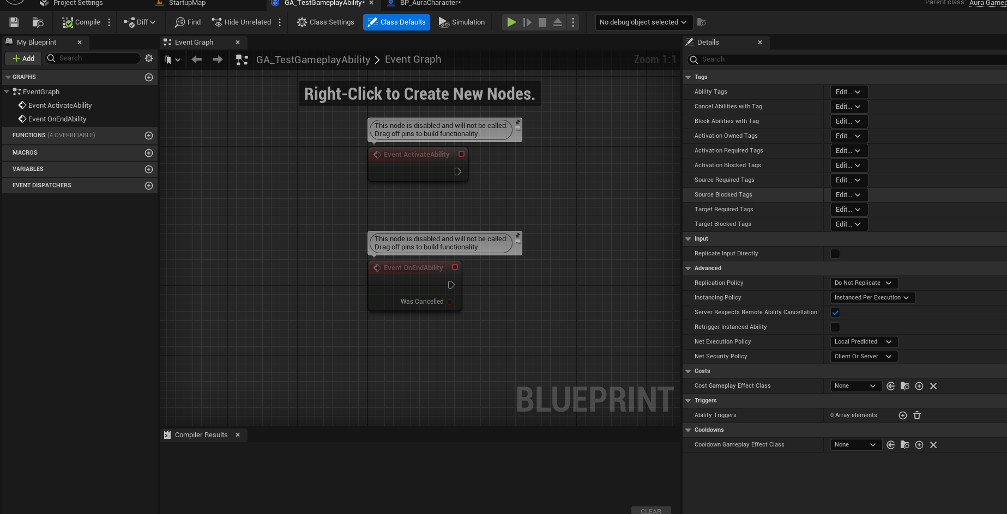

It has Event Activate and Event OnEnd nodes

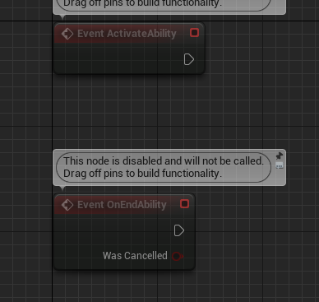

We can also use C++ functions, but we have events here

Testing:

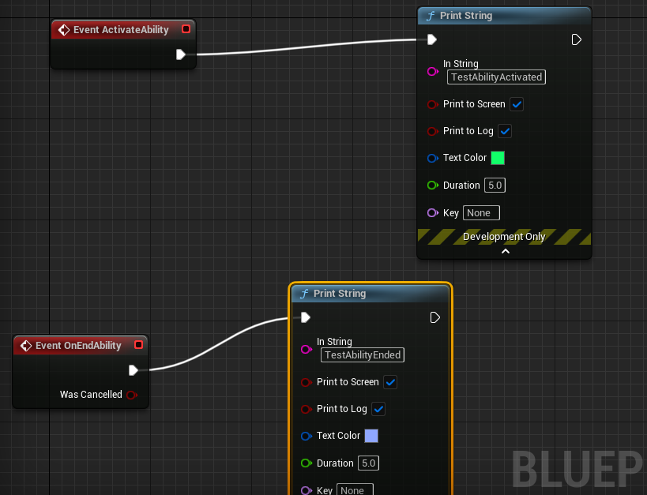

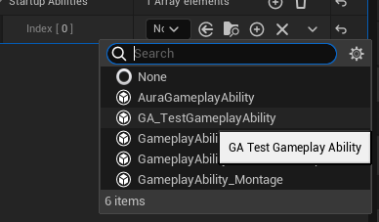

Now, pressing play should grant and activate this ability on press play

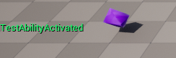

Done, it’s active. But there’s no End Ability print string – Event OnEndAbility was never called!

Events can end themselves

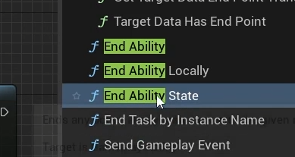

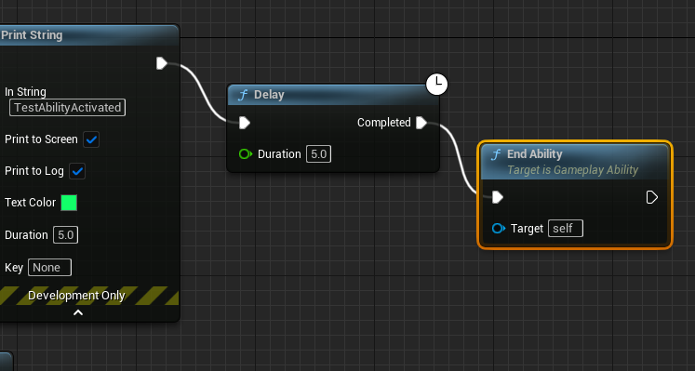

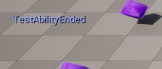

# Settings on Gameplay Abilities

New GA_Test has been created, and is based on the C++ implementation of the Gameplay Ability class

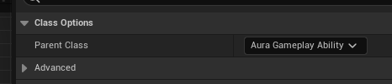

Lots of options for the class defaults here:

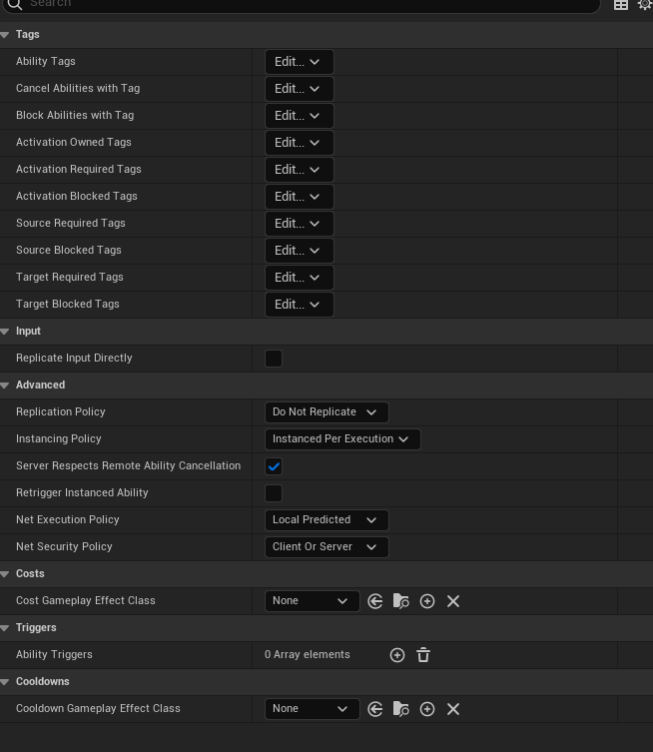

Tags:

You can add multiple tags directly to the ability from this page:

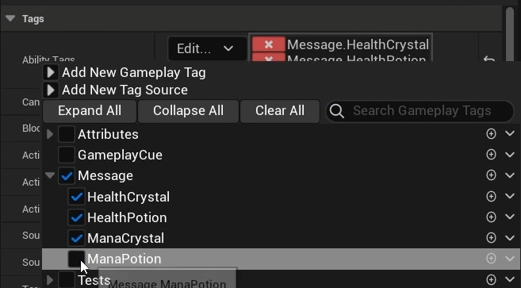

Each item has a mouseover that comes directly from the comments in the gameplay ability class in C++ and are self-explanatory

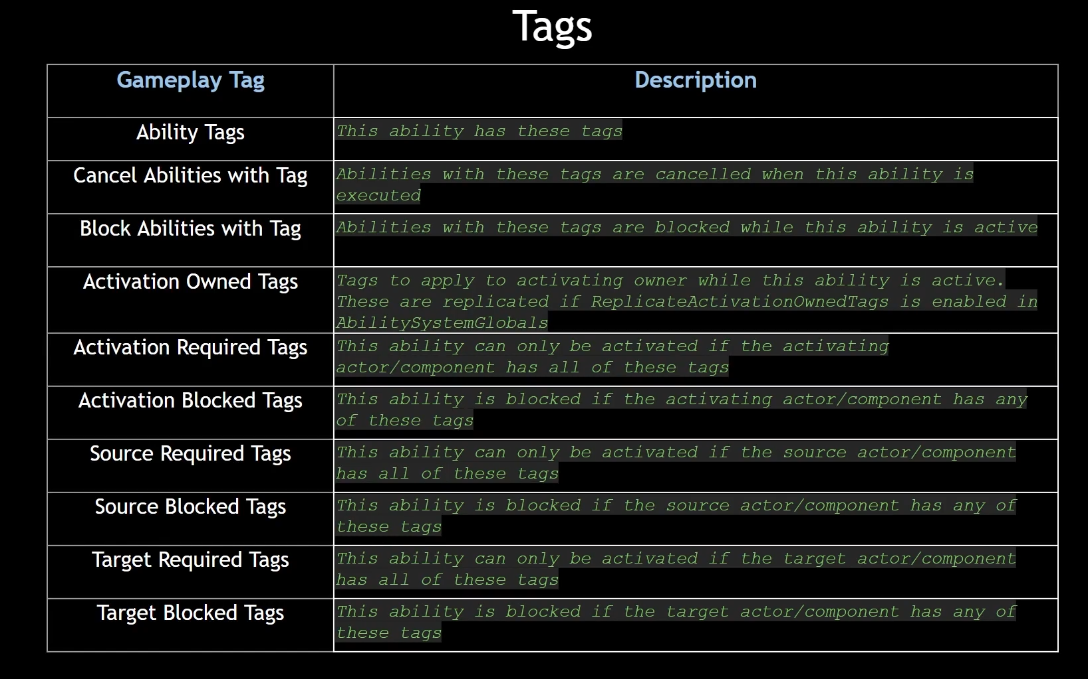

Tags explained in WoW terms

* Abilities have the concept of having tags, and they can be added here But why do we want tags?
* Cancel abilities with tag
* This ability will cancel other abilities that have a specified tag
* Ice Block is removed when you Blink
* Block abilities with tag
* When you use this ability, you cannot use OTHER abilities which have the specified tag
* Eg you cannot Fireball while you are in an IceBlock (wow mage)
* Activation Owned tags: Ability puts a tag on the owner, which can replicate - there’s a setting in Ability System Global to turn this on
* Icy Fingers wow? Build up secondary resources/combo points/holy power etc
* Activation Required tags: you can only use this if the owner has all the required tags
* Finishing move requires the secondary points to use/Ice lance needs icy fingers etc
* Ability is blocked if activating actor has tags
* Stealth if tagged as ‘In combat’?
* Debuff that blocks an ability like Forbearance blocks Divine Intervention – use with Activation Owned tag to put a cooldown on a target instead of the ability itself
* Source Required/Source Blocked: limitations on when an ability can be activated
* Target Required: eg can only envenom if target has poison
* Target Blocked: eg Cannot knockback target if target is rooted?

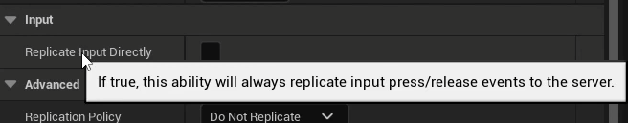

If you press input/receive input every frame that is sent to the server…not performance friendly? Encourages button mashing

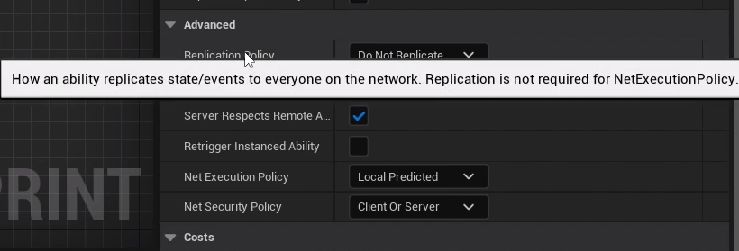

If we’re using Local predicted do we need to use a replication policy? Its set to Do Not Replicate; should we turn it on, or not? No, gameplay abilities are automatically replicated by default, no need to change this.

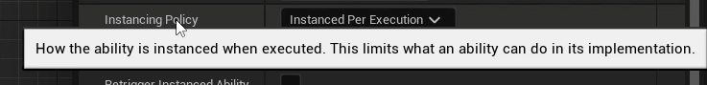

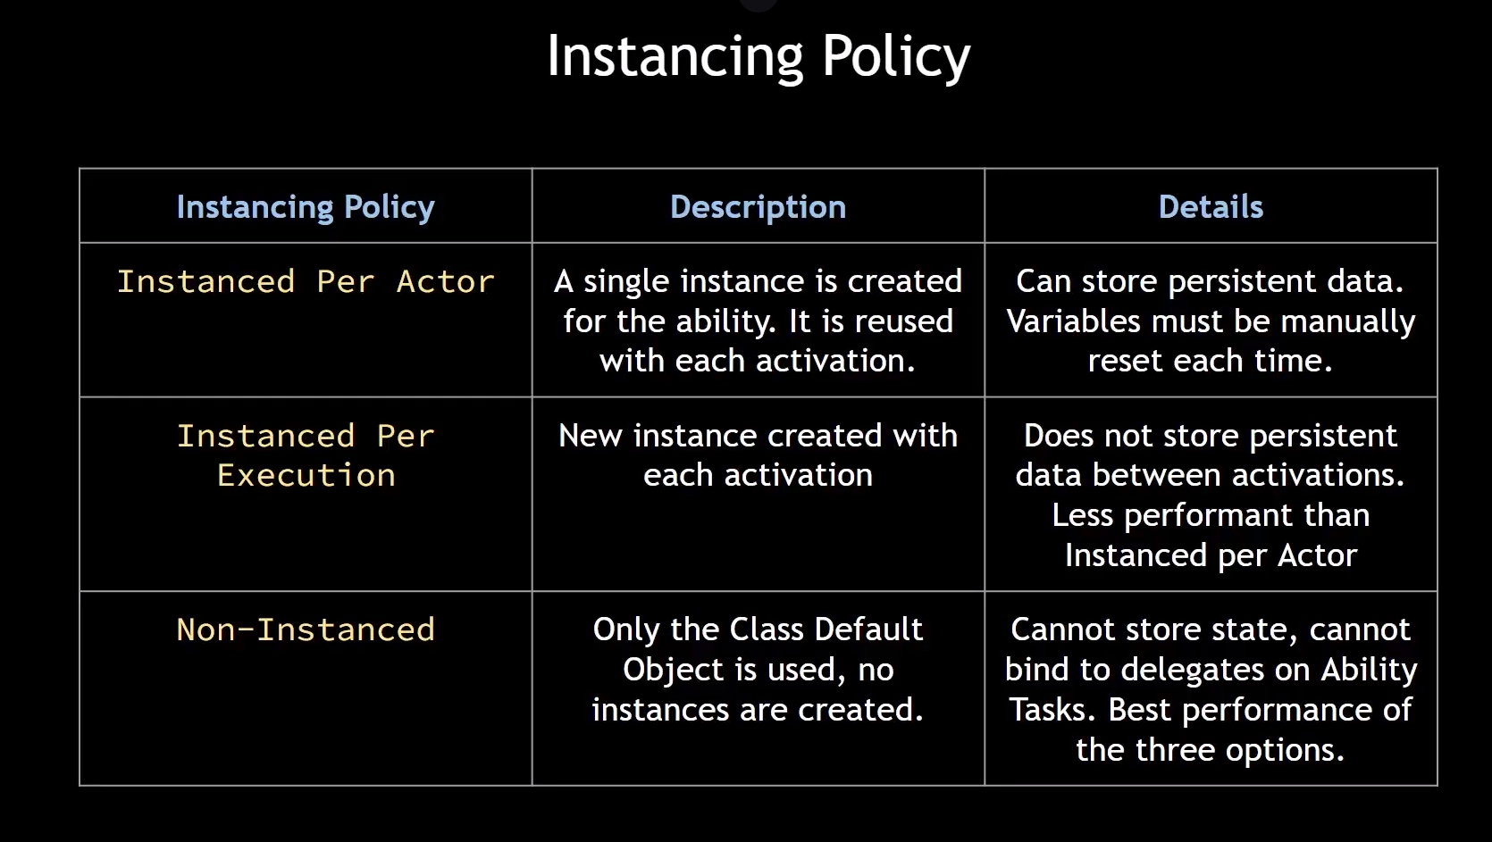

Gameplay abilities are classes that can be instanced.

Instanced per actor means we only make a single instance of the class upon activation. This one instance is reused every time it’s activated.

Since it’s instanced per actor, the actor is persistent, can store persistent variables and if you need to reset the variables you have to do it manually because the ability is never destroyed, it’s reused.

Instanced per execution: a new instance is created with each activation. Ability actor is created and destroyed over and over again. Does not store persistent data between activations because each activation creates a new instance of the class. Least performant option.

Non-instanced: class default object, no instances at all. Limited use, cannot store state, bind to delegates, never actually creates objects of this class. Like a static function library. Best performance.



“If you cancel this ability on the client, the server will be informed and will cancel it as well”

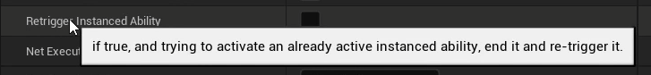

Self-explanatory, perhaps something like J-Boots from EQ?



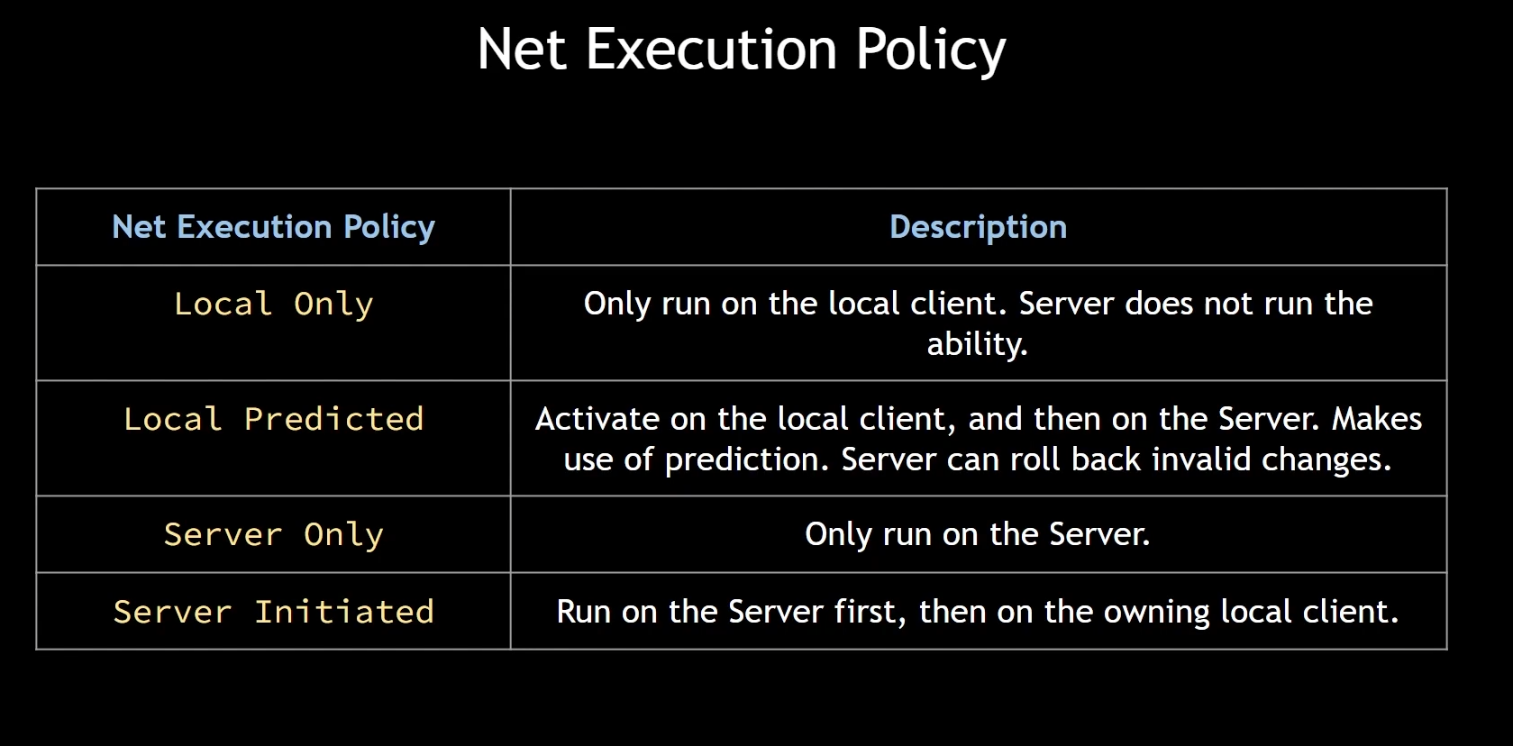

4 options

Local only: client only, server does not execute anything. Good for cosmetic only things that do not affect gameplay

Local predicted: Takes time to travel to server, which can roll back invalid changes.

Server only: passive gameplay abilities you want running all the time/listening

Server initiated: runs on server then replicates.

In this project Local Predicted is fine for most abilities

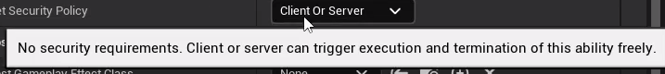

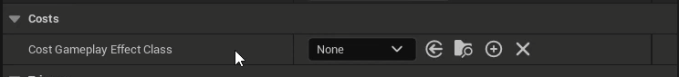

Gameplay ability has a resource requirement directly related to attributes. Costs are implemented in the form of gameplay effects, so make a gameplay effect, select it here to connect them. Eg Mana, energy for WoW rogues, Breath for swimming under water etc

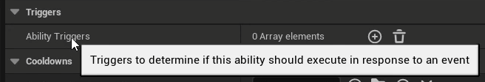

Allows the ability to be triggered in response to an event eg Reincarnation triggered in response to player death

Gameplay tag based:

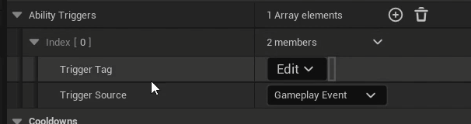

Possible sources:

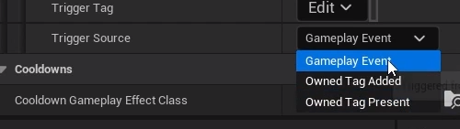

For example cleric resurrection

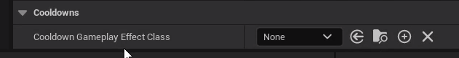

Gameplay effect based

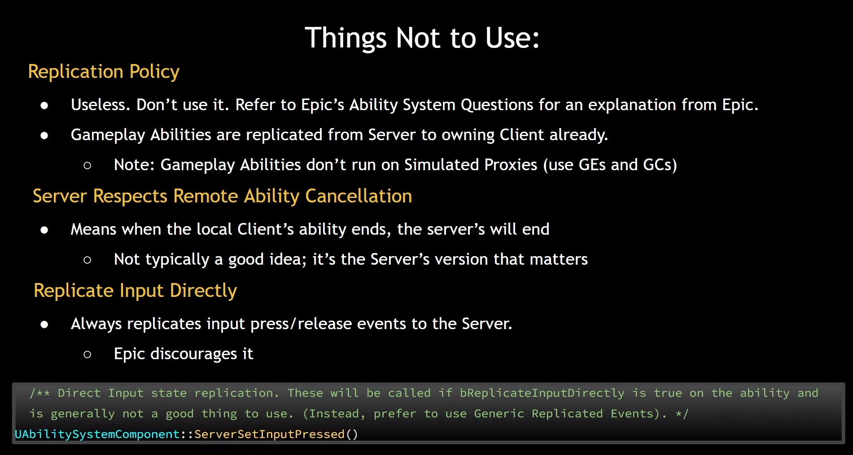

# Input Config Data Asset

Immediate activation works, but it would also be desirable to activate abilities via input

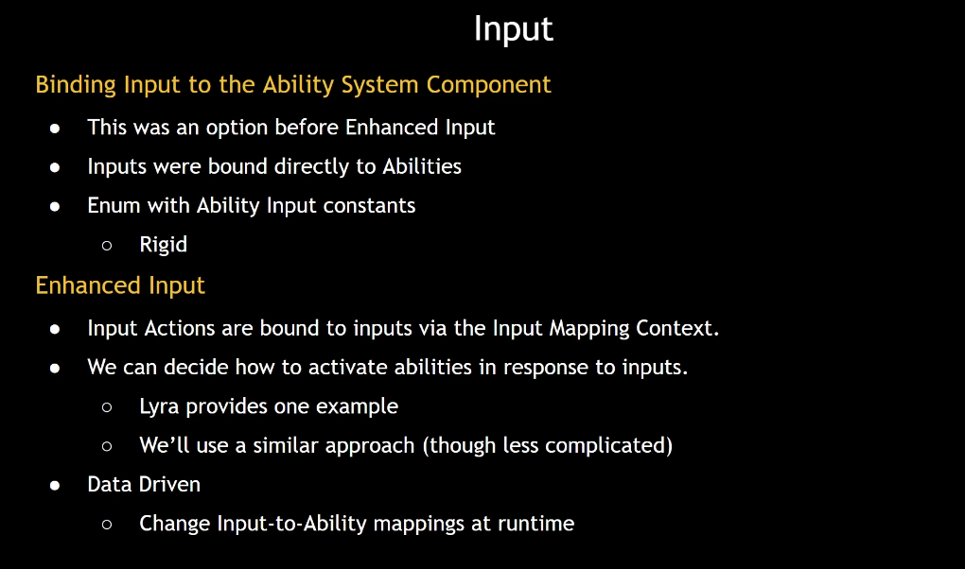

To do: create a data asset that contains input actions but link up input actions with gameplay tags

At runtime we can assign various tags to gameplay abilities – as abilities are activated every ability is associated with the tag which can be checked and changed

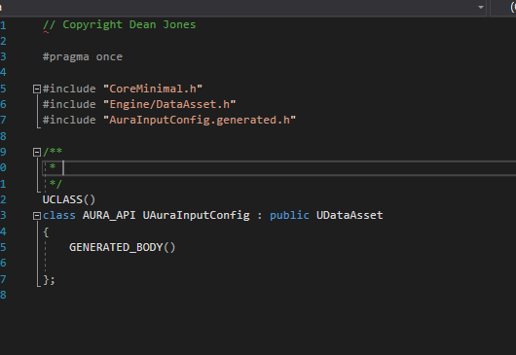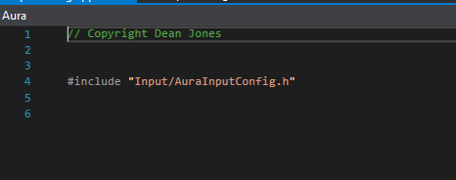

Target: an array of input actions, nothing too complicated, but the input actions need to be linked to gameplay tags

Easy way to do this is how Lyra does it, a struct with an input action and a gameplay tag

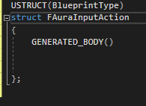

Struct will contain an input action: will be a const and we’ll forward declare the class to avoid including the header file, and initialise as a null pointer

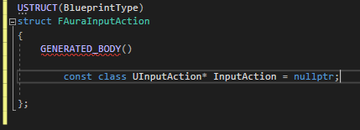

And a tag

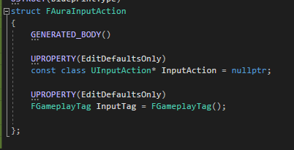

Now that we have this struct our data asset can contain an array of these that we can set in the data asset blueprint

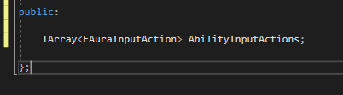

This array will be populated with input actions

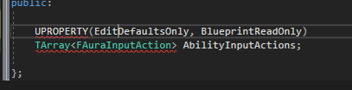

Specifically AuraInputActions that have a gameplay tag

If we have a pointer or reference to this input config we can look up any actions that have a specific tag

Function to do this:

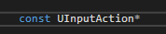

Why return an InputAction, not an AuraInputAction though? Because this will be more useful if we return just the InputAction associated with a gameplay tag, and so the struct is an internal element to the input config; we don’t have to worry about breaking it open and finding the action inside; we’ll do it here



This will return the input action associated with a given tag

Loop through the Ability Input Actions by const reference

For each action we check the association is not null and also if there’s an exact match to the given tag

Then



There’s also the bool for if we don’t find anything

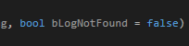

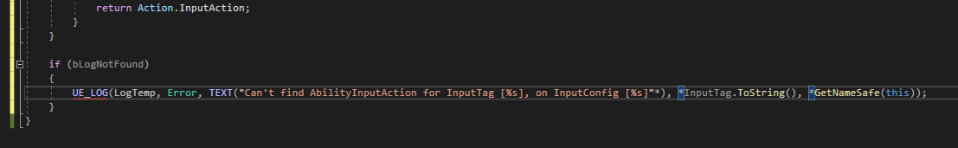

And finally since we have to return a pointer, we’ll return a nullptr

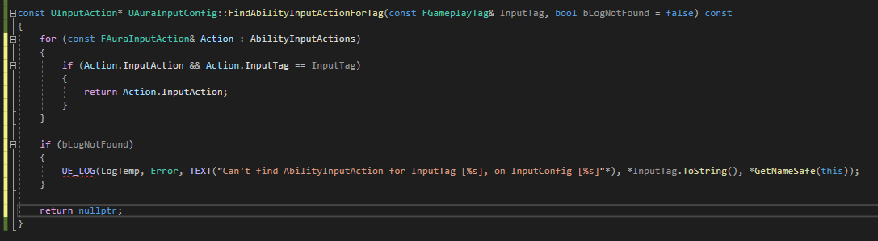

So now we have a function to find an input action associated with a given tag, which only works if we link up tags to input actions by filling out the data asset

We also need Input tags for any of the inputs we want in the game

We can add these natively to AuraGameplayTags.h

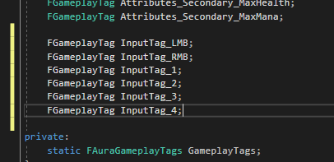

And initialise in AuraGameplayTags.cpp

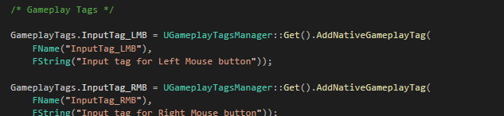

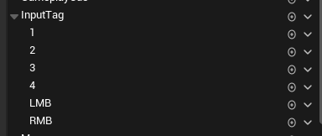

Tags are in the editor!

Add new data asset:

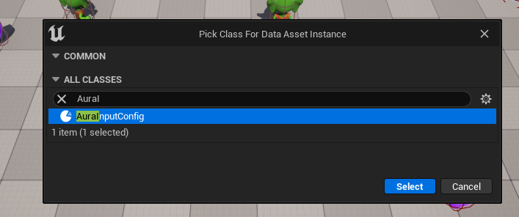

We can add new Ability Input actions, but we need to make the input actions first. They are one-dimensional IAs (move is 2)

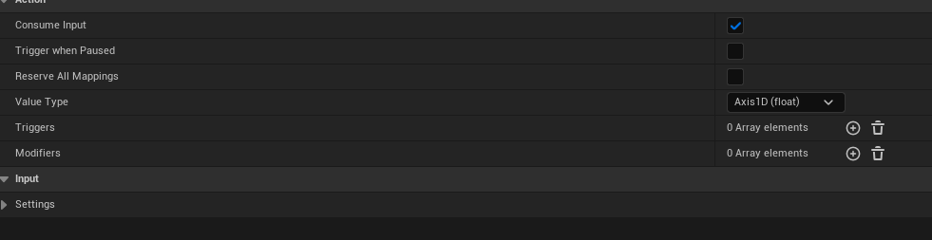

IMC links physical input to IA

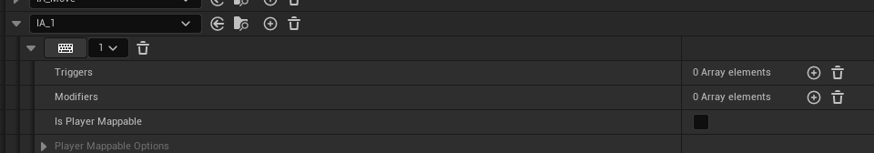

The Data Asset linking IA to tags

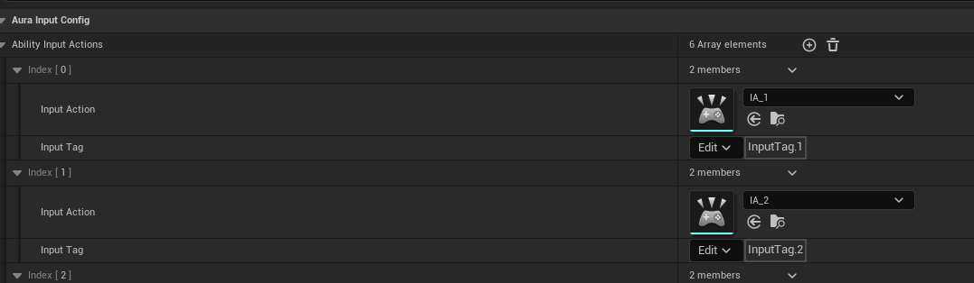

A little tedious but it means the data assets can be swapped out dynamically even at runtime

# Aura Input Component

Now that we have an input config we want a way to bind callback functions to inputs

We did this previously in the player controller

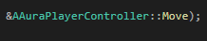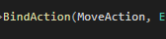

This was done using a function on the enhanced input component called BindAction



Let’s check out the definition for how this works

Here’s one possibility:

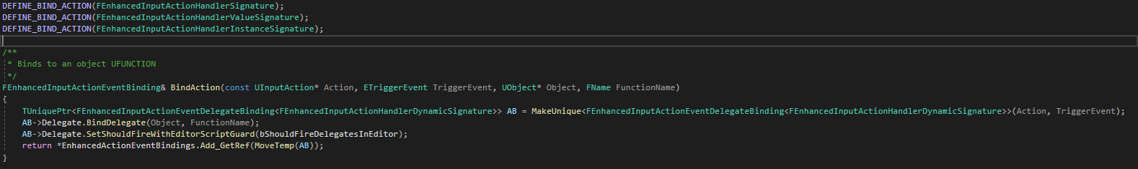

* It binds to an object UFUNCTION
* It takes a trigger event
* 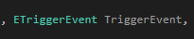
* A UObject
* 
* And a function name
* 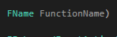

The function name is the clue that this isn’t the one we’re using for this next part! We’re passing in a function rather than a function name; this is a little bit above the definition of the one from the controller

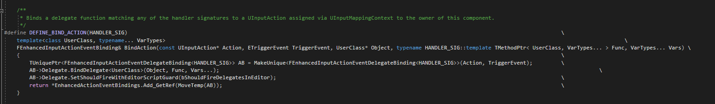

This looks like a very complicated definition so we should break it down

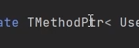

There it is, a wrapper for a function pointer

Let’s look at the variatic inputs:

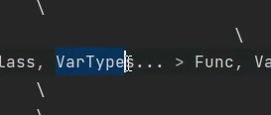

This seems to indicate that this template function can take a variable number of arguments

It can in fact take a function that can take zero or more parameters

So what we can do is bind functions to inputs that can take input parameters eg gameplay tags

We’ll use BindAction, and loop through the input config (which has an array of input actions) and bind functions for those input actions

We’ll do this on the player controller

Currently the controller is simply calling BindAction on the inputcomponent, but we could have our own custom inputcomponent, so that the player controller doesn’t have to take care of things that the input component should be taking care of

The player controller should just call a single function and pass in any function callbacks that we want to bind for any given input. In fact, we could pass in the whole inputconfig data asset to the input component and let the input component handle it.

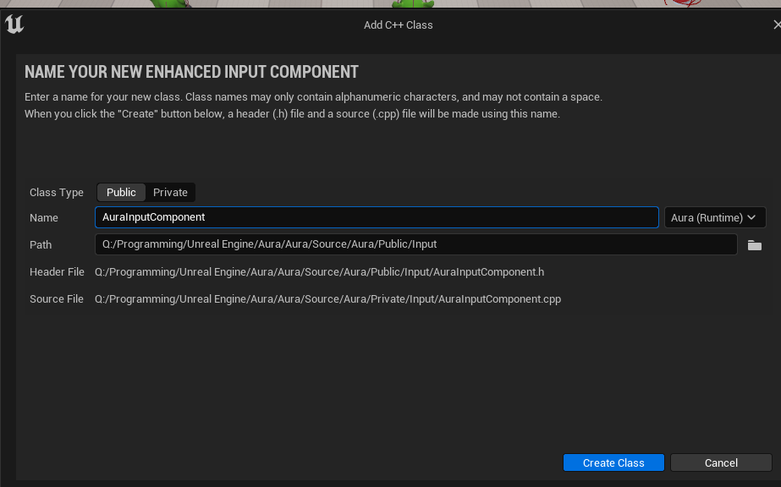

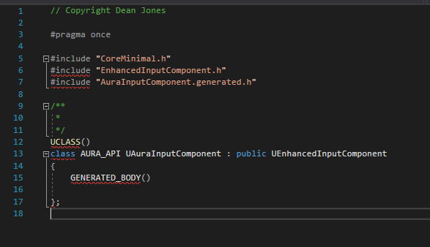

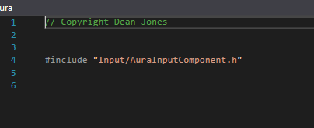

This new class is an EnhancedInputComponent class

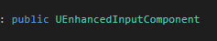

Configured correctly, we can set the project to use this as the default inputcomponent

First we want a function that can be called from the player controller that will bind inputs to callbacks, and we want those callbacks to be parameters to a function – we want the function to just handle things

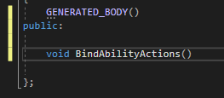

This will bind input actions for the abilities and take an input config

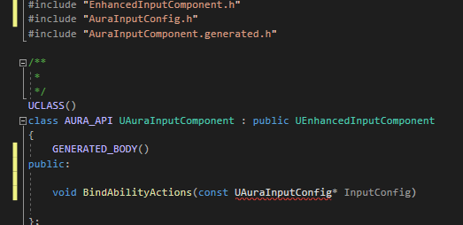

Using an include instead of a forward declaration is because we’re going to make this into a template function. If it’s a template function we’ll define it in the header file

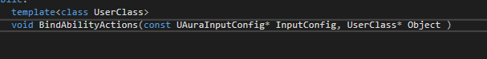

Using the template parameter and they class we’re using is UserClass, which will be that type (a pointer to it, because we’ll be calling BindAction which requires a UserObject

We’ll have other types as well:

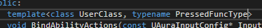

This will be of the type that we’d like to bind when an input is pressed



We’ll do the same for a HeldFunction and a Released Function

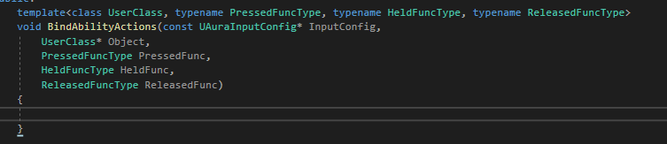

So we can have functions that we can bind to all of the input actions when they are pressed, released or held!

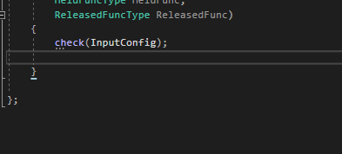

Inputconfig should not be null

Next we loop through the InputConfig’s InputAbilityActions

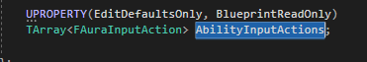

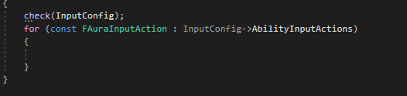

(it’s a public variable after all)

So what will we do for each item we loop through?

Bind the pressed, released and held functions for each

Why bind the SAME functions to all of the inputs?

Because we can pass along a gameplay tag!

So if we combine these functions to all the input actions, and we can identify those inputs by tags

We can pass those to the ASC, which can decide what to activate

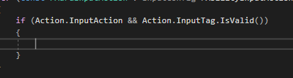

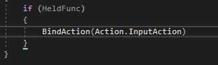

If we’re holding the button down we’ll call the Bind on the input action and the ETriggerEvent triggered, which operates every frame

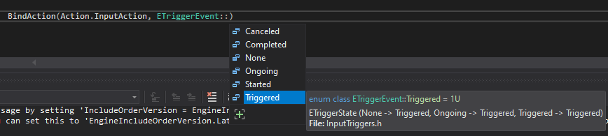

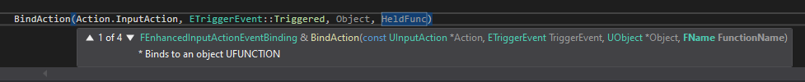

Next is the Object, and finally the HeldFunc

NB: This template is able to take in a variable number of arguments, and if we pass in more than this those will be passed along to the Held Function and the Held Function – if we make one that can take a gameplay tag, will receive that tag! So we’ll also pass in Action.InputTag

Now any action, along with it’s associated input tag, will be passed along into it’s callback!

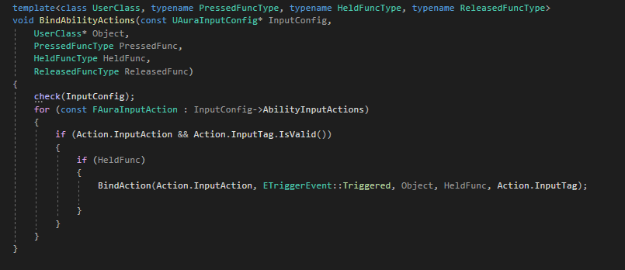

As long as the input is held, this callback will be triggered every frame

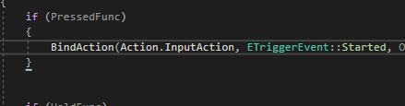

Started: as soon as the input is pressed, the function callback we’re going to bind to it is called only once

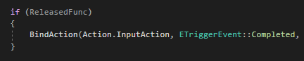

Completed: callback will be called when we STOP holding the input

So now we have this function that, when we pass it, we pass in an inputconfig data asset, a User object and functions – callback that can receive gameplay tags, and they functions will be bound to each of the actions for pressed, released and held!

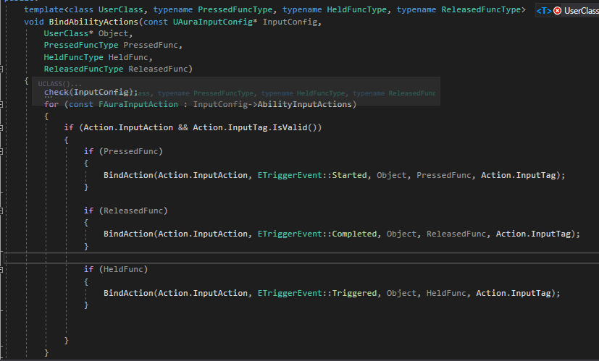

Now we just need to tie it all together by going into the player controller and calling the function

# Callbacks for Ability Input

BindAbilityActions takes:

* InputConfig
* Object
* 3 functions
* Pressed
* Released
* Held
* Is a Template type
* - can handle WHATEVER is passed in provided that what BindAction does to it supports those types
* What it supports is function types
* Even functions that themselves can take input parameters

How Bindactionworks:



Takes a function (PressedFunc) and followed by that function we can pass in inputs that will be passed along into those callbacks when the input action is made (pressed)

To call this in the player controller we need 3 callback functions : An AbilityInputPressed, AbilityInputReleased and AbilityInputHeld that we can bind to these functions above

We shall also add a data asset to the player controller for the input config and forward declare the type

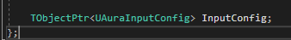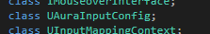

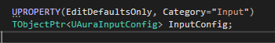

Now we have the input config we need the 3 callbacks

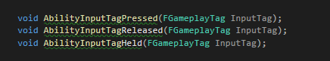

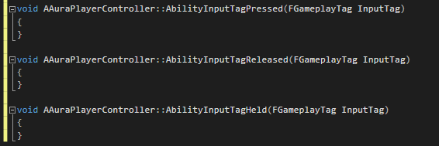

We’re not using References here, for the gameplay tags, so in this scope they are an undefined type

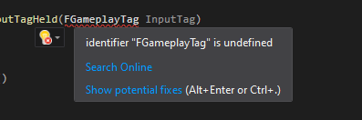

The easy fox is to include the GameplayTagContainer in the header file

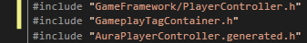

Now we need to bind our 3 functions to all the inputs in the data asset, the input config. We’ll do that in the SetupInputComponent

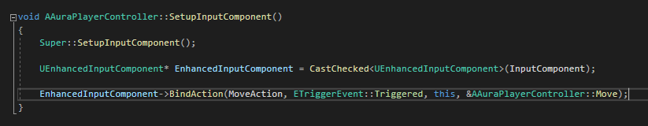

We’ve not yet set the new custom Input Component to the projects input component yet, but we will. So, rather than casting to UEnhancedInputComponent we will now cast to UAuraInputComponent

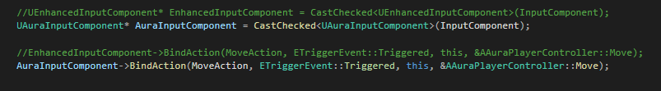

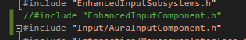

Now we’ll call the function on AuraInputComponent::BindAbilityActions

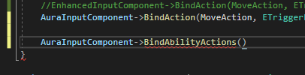

The first argument is the data asset, followed by the object



Next the 3 functions, by pointer. We can actually do it like this:



Corrected some errors:



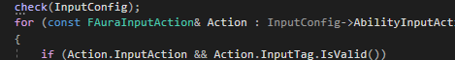

Now, provided we set our input component to AuraInput Component (we’re casting Checked so we have to or the game crashes), thanks to BindAbilityInputActions, when we press an input in the data asset the callbacks are fired.

Prove with debug message:

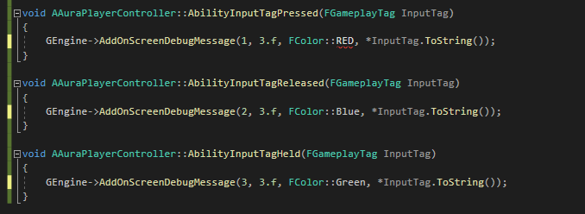

NB: FColor::Red, not RED

In Editor:

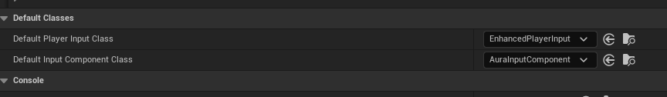

In player controller:

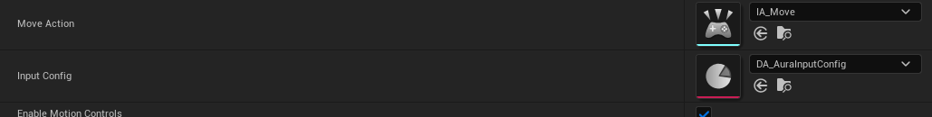

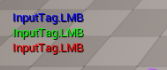

Pressing and holding the input causes Red and Green; holding input allows the Red to fade but Green continues, releasing causes Blue.  
  
We now have Data-driven input, which is super powerful, because we can swap out or configure the data asset and everything is associated with input tags

Now that we have these three callback functions, we can use the tags to activate abilities as long as abilities have tags associated with them

Next step is therefore to associate the gameplay abilities with an input tag – swapping out the gameplay tag for a given ability allows us to remap it to a different key at runtime!

Nb: since the functions do not require any member variables or anything that requires an instance of anything to exist, we can make them statics

Also cursortrace could be refactored and made more compact

# Activating Abilities

There are now 3 callback functions and we’ve bound all three to the input actions. We want to activate abilities and to use the input tag to identify those abilities

Abilities can be associated with tags in any number of ways, and if we start the game with abilities those abilities should be associated with a tag by default so we know if we press that particiulae input we can activate that ability

So adding a gameplay tag variable to the Aura gameplay ability class

Class will have member variable for startup input tag

Gameplay ability might have tag changed at runtime, so this variable really for the startup tag, only applies of this is a startup ability

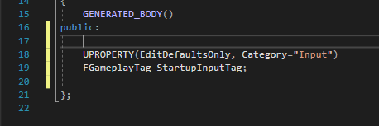

The tag can be set on the gameplay ability (class default object) and is category Input, but this is not something we should change at runtime – abilities have different instancing policies and really it’s the GameplayAbilitySpec we’ll be using throughout the game so StartupInputTag is only good to check at the very beginning when giving ability to character

In ASC:

We want abilities to have the concept of a startup input tag, but also want to change it at runtime eg ability is mapped to RMB, want to change that to LMB, so variable on the gameplay ability class great for something like the StartupInputTag, but If we want to change it we can’t use vars on GameplayAbility class.

Gameplay ability spec has a container for dynamic tag add/removal – perfect for this and as the ASC adds the abilities for the first time we can check that startup tag and add to the abilityspec for a given ability

Right after creating the spec we can get dynamic tag container and add to it with add tag function

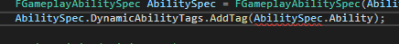

Ability is the actual ability that the AbilitySpec is a representation of

If that Ability is not a nullptr then we can get variables on it

Ability here is a simple UGameplayAbility type object. So we have to cast it to get the member variable StartupInputTag

We’ll cast as part of the For loop that exists already

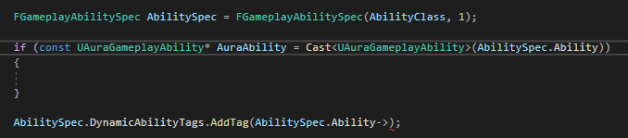

We need to Abilityspec, so it needs to go after the AbilitySpec definition line

So, IF the Abilityspec.Ability can CAST TO an AuraAbility we are now able to get that AuraAbilty and access the startup tag from it

So we move the Dynamic tag into the If check

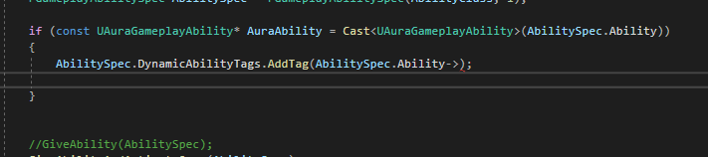

And we’ll also replace the AbiltySpec.Ability with AuraAbility->StartupInputTag!

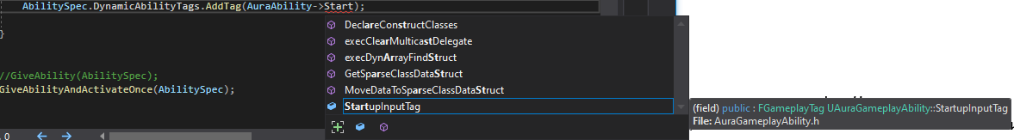

Now if we’re looping through the abilities, and if any are derived from AuraGameplayAbility we get that startup tag and add it to the dyanamic ability tags container, and as soon as that is done, we can give the ability

We have seen previously that we can give the ability and activate immediately with “GiveAbilityAndActivateOnce(AbilitySpec);” that was a p[roof oc concept, so we’ll not use that, just GiveAbility now

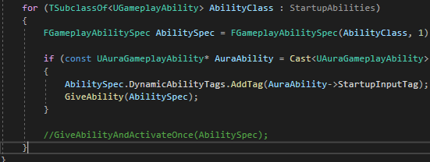

So, as soon as we have added that tag to the abilityspec’s DynamicAbilityTags, we’re giving the ability. Now as the startup abilities are give to the character their tags will be added to startupability tags

Dynamic Ability tags are designed to be added and removed at runtime so we can change this later!

Nb AbilityClass can be made const, so let’s do it

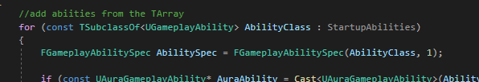

So, now the startup abilities have in their dynamicability tags, and Input Tag. All the Input tags start with InputTag.*something.* So they’re easy to identify, useful when we activate them

In AuraPlayerController, when we activate the StartupAbilities, all we’re doing with them right now is debug messages.

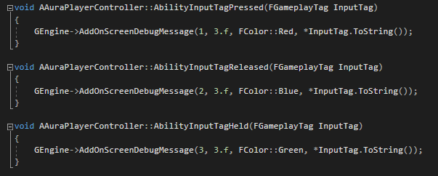

What we can do instead is call some function on the AbilitySystemComponent, passing in the InputTag and telling the ASC “We’re doing this input, so if there are any abilities that have this InputTag assigned, activate them”. The ASC will see if we pass an InputTag over that corresponds to one of its activatable abilities and then can activate that ability

We’ll add some new functions to replace the Log output lines:

* Function for when an input is pressed or held
* Function for when an input is released

For activating abilities, really only concerned with when an input is held and released – if an input is pressed for the first time this is something we can know if we’re holding an input anyway, based on whether or not an ability is currently activated

The two functions will be in AuraAbilitySystemComponent and will be public in scope:

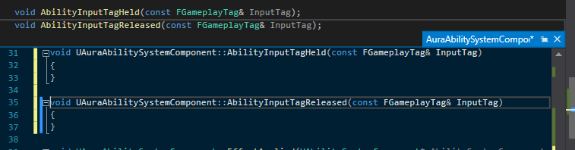

They will both take const references to input tags and we can call these functions from the player controller

For Controller::AbilityInputTagPressed we’ll access the ASC and call it’s AbilityInputTagHeld

We don’t want to cast every single time we use this input – because AbilityInputTagHeld might be called every frame!, so in the player controller.h we’ll add a new variable to hold the ASC, so we can cast only once and save resources

So we’ll fwd declare the class

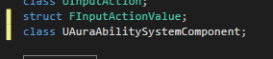 

And we will set it the first time we acess, so will add a new function that returns a pointer to it

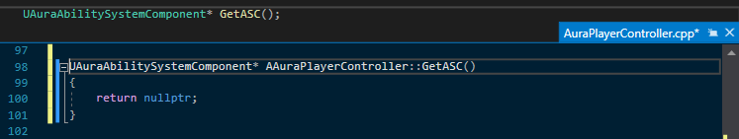

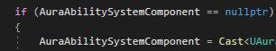

If the AuraASC is a nullptr (which it will be the first time we call this) we’ll do the cast here

The easiest way is the one we already defined in the Blueprint Library!



GetPawn requires a template parameter type, APawn is fine



So calling GetPawn and passing that into GetAbilitySystemComponent gets us that ASC and that can be cast to the AuraSystemComponent



So, if the variable is null it’ll attempt to get it

This cast could fail however – it could be called too early or the ASC isn’t set yet…if so it’ll return a nullptr, but as soon as the function is called for the first time that the ASC on the pawn is valid, we’ll get a valid ASC and it wont be null from then on

We’ll now only cast once, so when we get the ASC from the AbiltyInputTagHeld, we won’t cast every frame

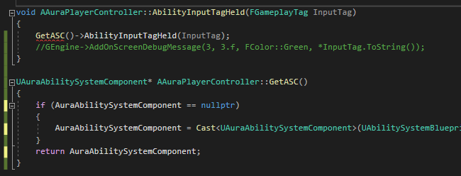

Because GetASC could return a nullptr, we’ll add a check

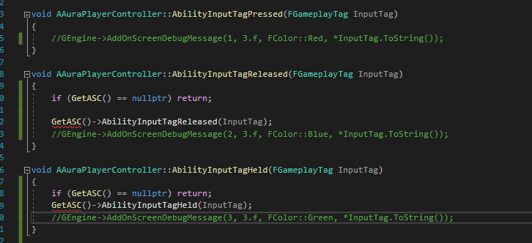

Now it’s up to the AbilitySystemComponent to handle what happens when we press these inputs

What does the ASC actually do? Well, we’re giving it at least 1 startup ability and we can set its startup input tag

ASC should:

Check to see if any activatable abilities associated with the tag

Activate if already active

We don’t necessarily want to activate every frame, so we will also check to see if they are active

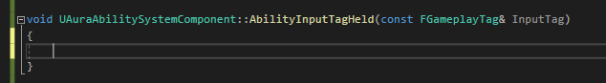

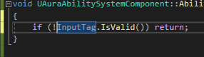

Next we check of the ASC has any activatable abilities will this input tag

We have a function that contains all of the activatable abilities: GetActivatableAbilities()

This returns a TArray of GameplayAbilitySpecs

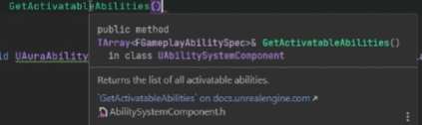

Activatable abilities means abilities we have that can be activated – recall we have all sorts of tags that can block activation, so this is the way to get all the abilities that we can activate

We can loop through these

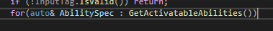

Auto here is an FGameplayAbilitySpec

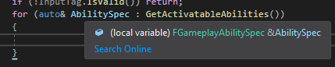 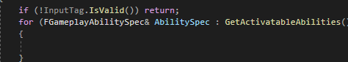

So, we’re looping through the GameplaySpecs in Activatable abilities, but we don’t want to activate them all, only the ones that have the specific InputTag

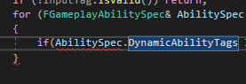

DynamicAbilityTags is an FGameplayTagContainer, so it has functions like

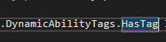

And HasTagExact

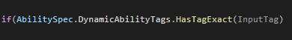

If yes, we now have an ability that has an Input Tag in Activatable Abilities that has the tag that the player controller passed over – we pressed that input

So now we want to activate it, if it’s not already active

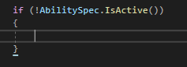

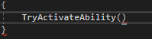

This requires a spec handle, so we can take the AbilitySpec and extract the handle

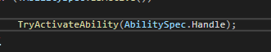

We have to call the TryActivateAbility, because there may be things that prevent the ability activating

Abilities themselves have the concept of input being pressed/not pressed so we can check at any time if an ability’s input is pressed or released and decide what this means and provide custom functionality

To tell an ability its input is being pressed we call “AbilitySpecInputPressed”

This requires the abilityspec

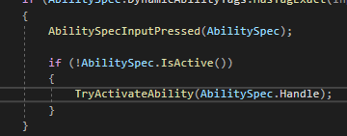

It basically just sets a Boolean on the ability spec to keep track of if it’s input is pressed

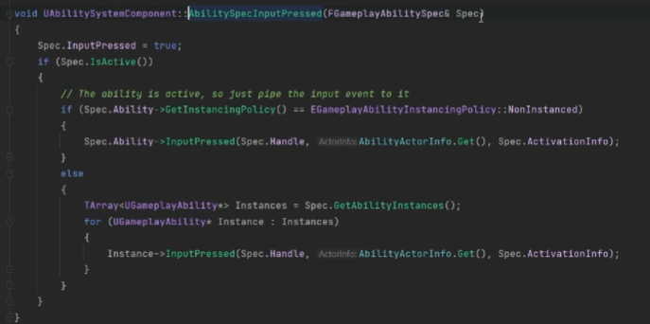

The function checks if this is an instanced ability; if not, it gets the single instance and sets pressed, if it is, it will call for each instance

So the ability itself has an input pressed function:



It’s a virtual that is not implemented so we can override

AbilityInputTagReleased will be similar, but rather than JUST end an ability is the input is released, we’ll let the ability decide – not all abilities need to be cancelled/ended on release. Some abilities we’ll press and release right away and we don’t necessarily want to end that ability as soon as it’s released. So all we’ll do in the ASC is tell the ability “You input is not being pressed any more”

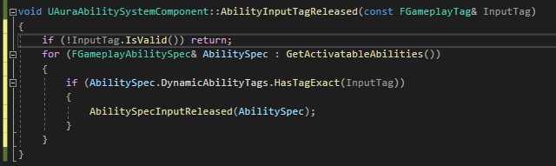

Time to test!

In the editor in the TestGameplayAbility, the the GA_TestGameplayAbility:

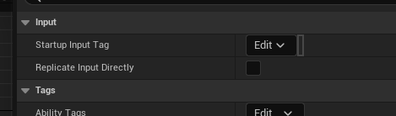

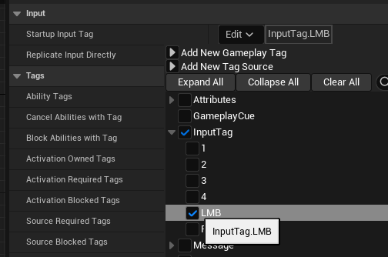

So, this ability will not be active by default, but will activate on the left mouse button being triggered; stay active 5 sec, then end itself. It should only be able to be activated if not already active

# Click to Move

Now there are inputs and callbacks to respond to the inputs time to start implementing abilities

This is a top-down project so adding click-to-move!

How to do it:

UE has a top-down template project, which gives a nice example of how it works…except for one limitation: if you set the number of players to more than 1 and use a multiplayer client, click to move does not work, only click to follow. In listen server mode the server character works in autorun but the client does not

Looking at the code for the template, it has callbacks bound to the EnhancedInputComponent

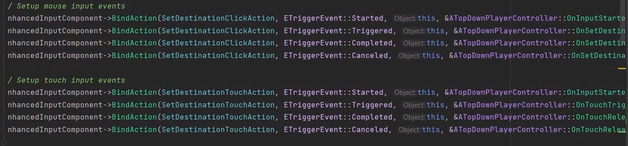

There’s a SetDestinationClickAction with various functions bound to it based on events

For Started all there is is a Stop movement

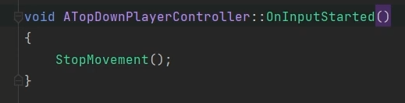

It’s in SetDestinationAndTriggered, which is called every frame as ling as the input is held, that things are interesting:

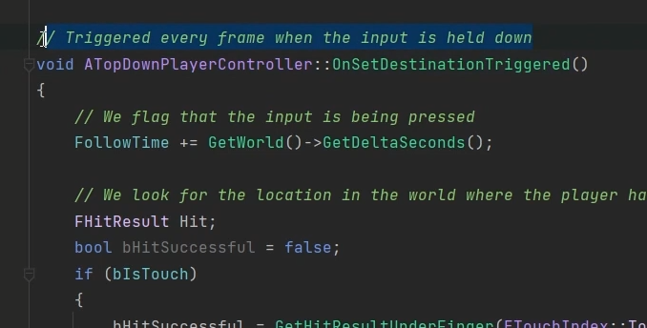

So in the frame we begin clicking, there’s a call to stop movement. If we continue to held down, we go into the next function

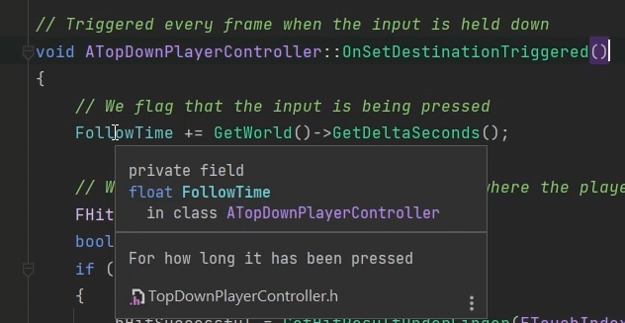

This member variable is a float and gets the deltasec and increments every second

Then there’s a hit trace creating a local Boolean

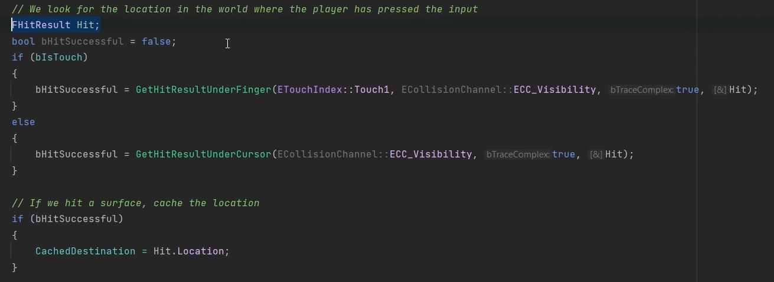

bIsTouch is for mobile, otherwise it’s for cursor

On a successful hit the location is stored in the CachedDestination vector

Once the location is stored:

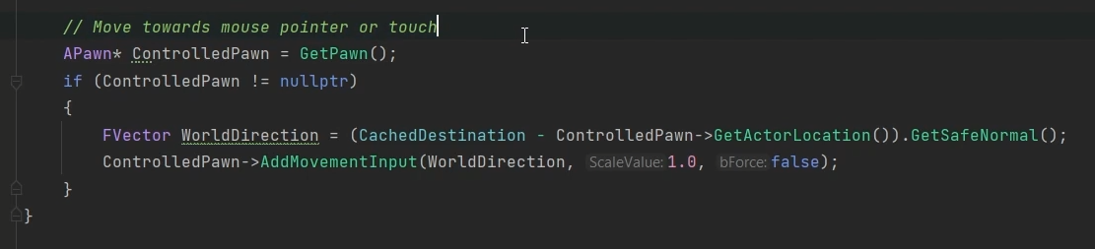

A vector is generated between the current actor loc and the destination, then a normalised vector is created, then AddMovementInput is called passing in that direction. This is all called every frame

AddMovementInput moves the pawn through the pawn’s movement component:

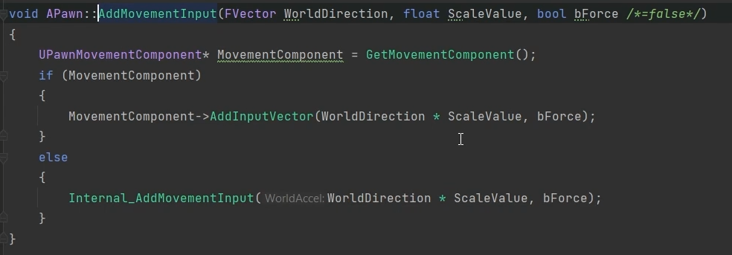

MovementComponents have built-in replication abilities, this is why holding down the mouse works in the template for the client and server but autorun only works on the server

OnSetDestinationReleased is bound to the Completed Event; when the mouse is released this callback is executed:

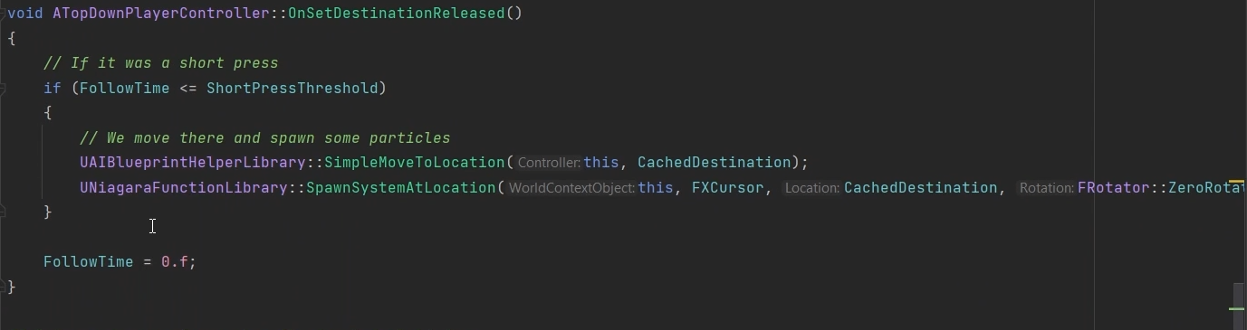

The followtime from the Held function determines if the release is from a short press or a long one with the threshold being some arbitrary value; at the end of the function the FollowTime variable is reset

Is the press WAS a short press (not using the follow mouse pointer from the held input) then we call MoveToLocation, passing in the CachedDestination

This function ALSO handles spawning a Niagara system at the location of the mouse press

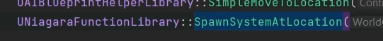

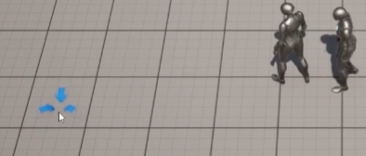

The arrow indicators!

SimpleMoveToLocation is an AI function

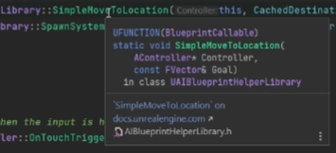

AI move functions are not designed to be called from a client, they are called on the server for AI characters. If that AI character has it’s movement replicated down to all client, no problem

But for a human-controlled character this won’t work! It’s fine locally, but there’s no multiplayer replication built-in

AddMovementInput has all sorts of lag compensation, prediction and other functionality built-in

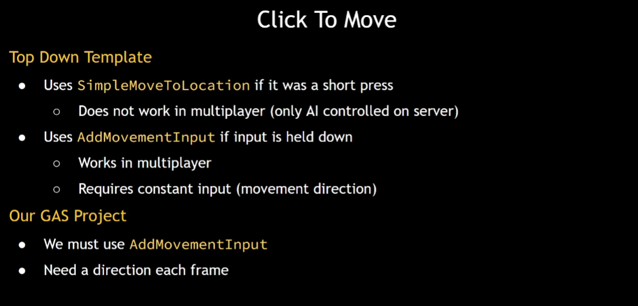

Implementation:

Mouse cursor and pawn each have a world location; we can calculate a direction based on those locations and add a movement function.

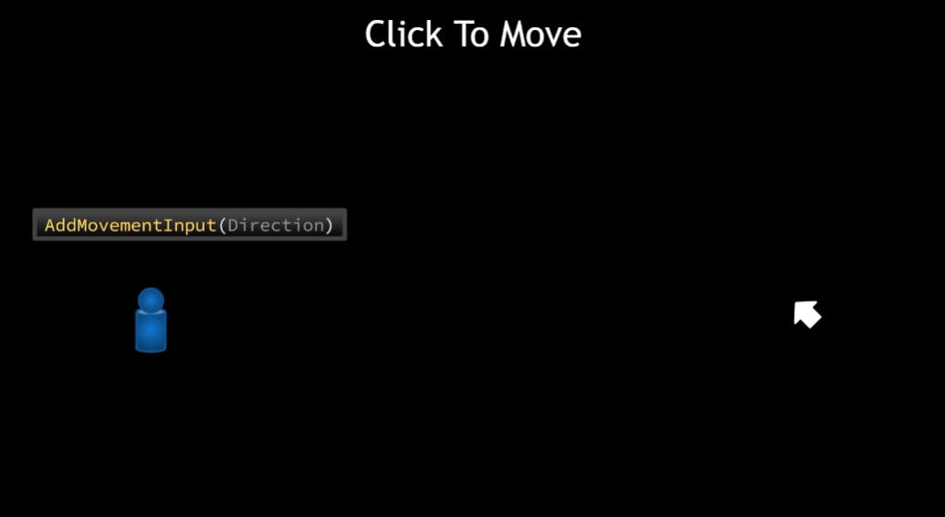

In multiplayer: If there’s an obstacle the straight line between the cursor and the pawn would intersect the obstacle

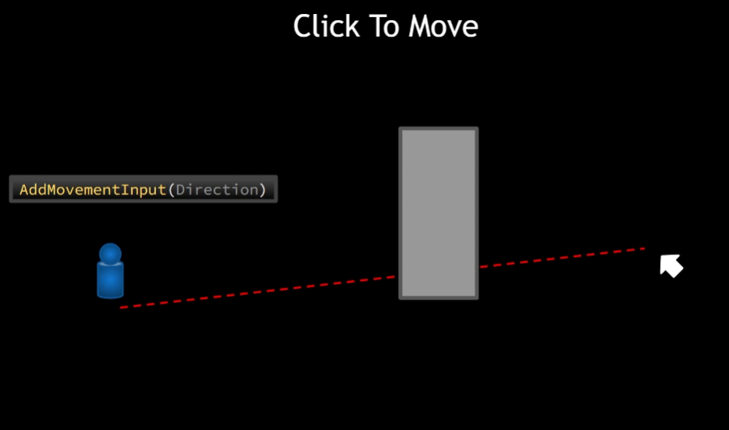

If we just follow the line, the character hits the wall and keep trying to move through wall, looks bad

Need pathfinding to go around the pillar

There are functions to pathfind but they can also look bad

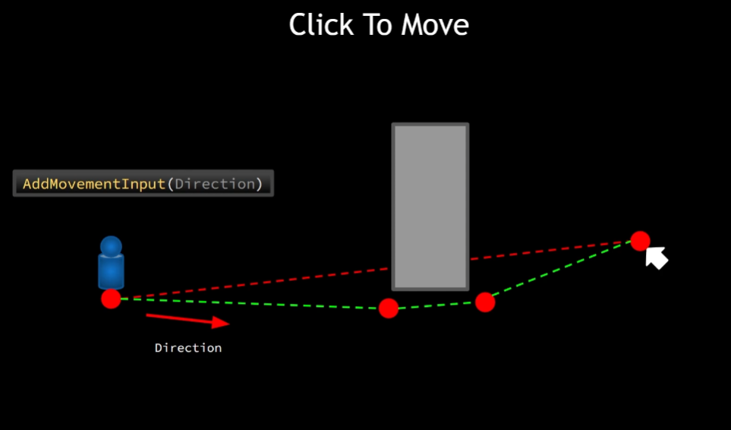

With these generated waypoints, we can move in a straight line to point A, change direction, then straight to B, change direction, then to the cursor

Can result in abrupt change of orientation which looks bad; the change might even be a snap.

If we could generate a smooth curve from the points…a spline, even better

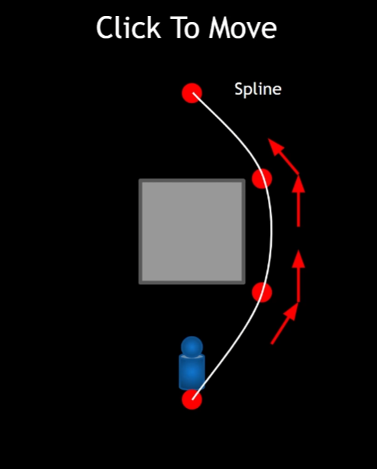

Get the forward direction at any time, tangent to the curve, continuous change of direction

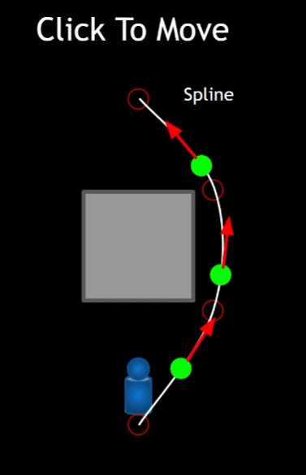

# Setting up Click to Move

Will need the player controller:

We’ll steal a little from the top-down template; but differently. Will need a few internal variables, which we will initialise

* If we click on a particular location we need to capture that location as a vector
* Keep track of how long we have pressed mouse button before releasing it

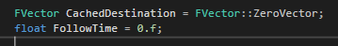

* We also need to know the short-press threshold – how long do we hold the cursor before releasing and how long before we consider this no longer a short press?

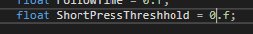

* If autorunning – if it was a short press and we want to generate some path points to move along a spline to reach the CachedDestination – we should know if we are doing this or not

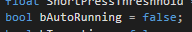

* That way, when this is true we can call the AddMovement every frame
* While autorunning we will get closer to the destination and then stop; how close we get to the destination should be a parameter we can set

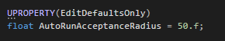

* Added a UPROPERTY so we can edit this in UE
* Will also require a Spline component to generate a smooth curve out of a number of world locations

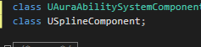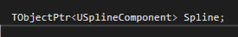

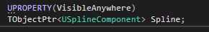

Since it’s a component variable we need to construct it

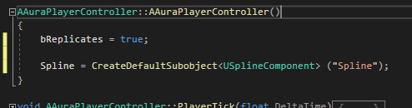

VS did not error, but we will need the include for this:  
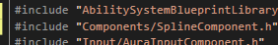

Other vars:

ShortPressThreshold isn’t really good as 0, so make it half a second

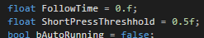

Others are find as they are; could be initialised in constructor as well as an option.

Consider what happens in the game, what happens when we click in the world?

LMD will be a special input, because used as click to move AND also to activate abilities assigned to the LMD

So, when we click, so we run or do we Activate? What is the criteria?

We already know when clicking if the mouse cursor is on top of an enemy, because we have the CursorTrace highlight – in any given frame ThisActor is a pointer that holds either an iMouseoverInterface or anything implementing that interface, and if not it’ll be null.



Therefore, if the mouse is over something that has this interface, we can activate the ability (or Try), and if not we can move to the cursor

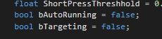

As soon as we click, we check to see if we are targeting. We do this by seeing if ThisActor is a valid pointer; if it’s not null

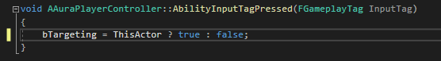

The ternary will return true if ThisActor is not null, else will return false. It’s functionally this:



If AbilityInputTagPressed is being called, then we have only just clicked with the LMB and are not autorunning. Therefore:

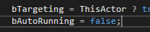

Because we do not yet know if this is a short press or a long press – we don’t know until the LMB is released

We also need to know if the button being pressed is the LMB, since it’s a special case

So, including the Gameplay Tags header

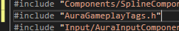

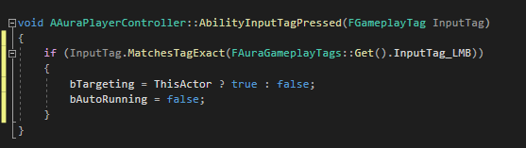

This should do for this function

Holding the LMB:

Using the same IF check we want to activate the ability if the input is NOT the LMB

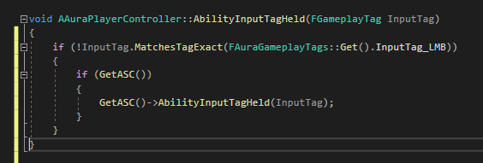

So, in this function, if we are holding down an input and it’s NOT the LMD, we tell the ability system “We’re holding this down, do the ability”

Otherwise, if it IS the LMB we are concerned about running, and we’re holding it down we want to know if we’re targeting

If we ARE holding the LMD AND targeting, we should also do the ability

So:

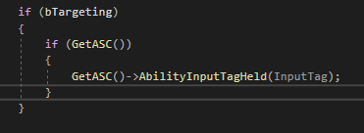

If ability is already activated above, we should return

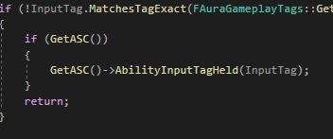

This will exit, whether the ASC is valid or not

Now the only cases remaining as if we are holding, and we are using the LMB, and bTargeting; or holding LMB and !bTargeting

We’ve just covered bTargeting, so the click to move behavior now belongs in this else:

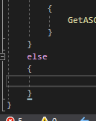

First thing: Increment the FollowTime, then get the hit result

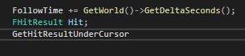

We are tracing against the visibility channel



So we check the visibility channel for a hit, we do not make a complex trace to avoid the hit being too complicated, and we pass in the Hit local variable

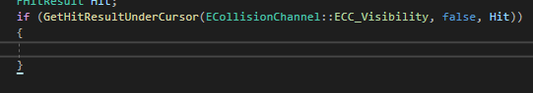

The GetHitResultUnderCursor will return a bool, so if we make it inside this If statement we can set the CachedDestination here

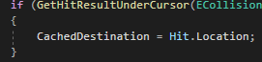

Now we have the target location and can call AddMovementInput. As we are holding the mouse down we’re getting a destination to move towards

To call AddMovementInput we need the controlled pawn

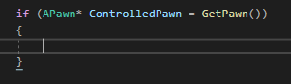

If the GetPawn returns null it does nothing; if it doesn’t return null we have a valid controlled pawn, and can now call AddMovementInput and pass in a direction

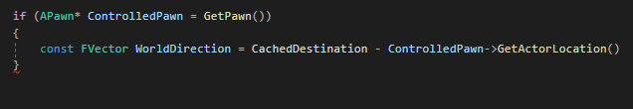

This is the vector from the controlled pawn to the cached destination, but we want a normalised vector, so we will wrap in parens and call GetSafeNormal

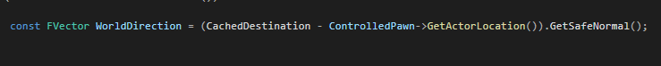

World direction established, so we take the pawn and

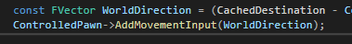

(some of the params here are optional)

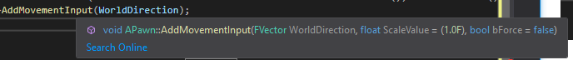

This will handle holding down the mouse to move

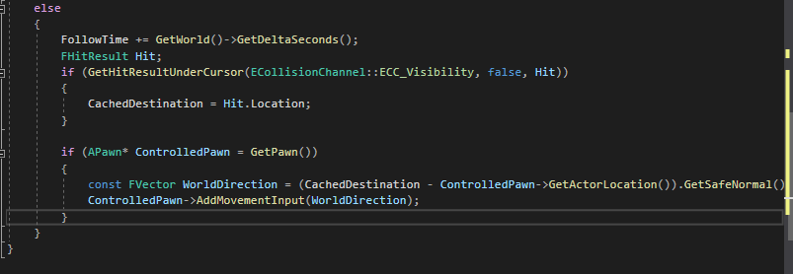

…and it’ll only work if we are not targeting something :D

# Setting up Autorun

Click and hold now works, but we also want to click and release and get AutoRun

This is in AbilityInputTagReleased

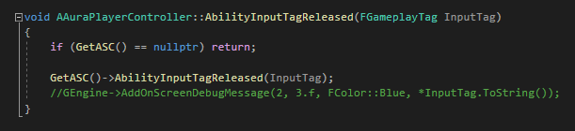

We want to know if we release an input is it the LMB? So we can copy in those lines

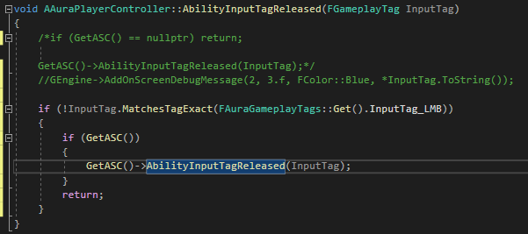

If it’s not the left mouse button we want to call AbilityInputTagReleased

If it IS the LMB we should check for targeting and if yes:

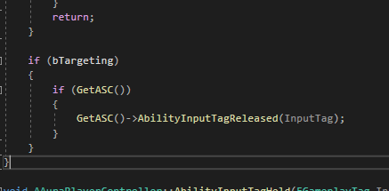

The final case:

* It IS the left mouse button and
* Not targeting

So now we click to move

In the Held function, the actions which we took were:

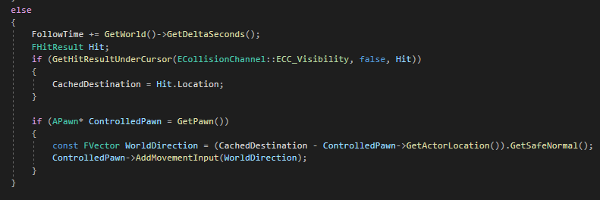

Collect the FollowTime and then adding movement input on a frame by frame basis. So when we release we should check the Followtime to see if it was a short press or not

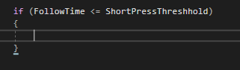

If yes, we want to create a navigation path.

There’s a function in the static function lib UNavigationSystemV1 called FindPathToLocationSynchronously

So we need to include 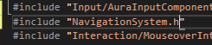

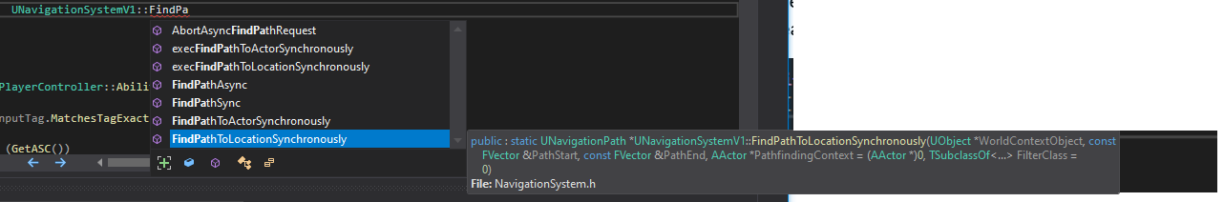

Arguments:

WorldContextObject: this

Pathstart: Controlled Pawn’s location

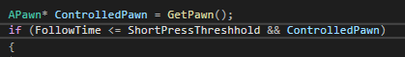

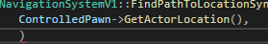

Path End: The CachedDestination

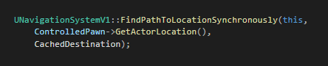

This returns an object of type UNavigationPath which we can store in a local pointer

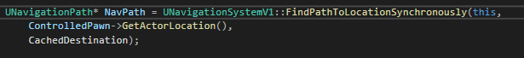

And if we’re going to check this pointer, we might as well just wrap it in an IF

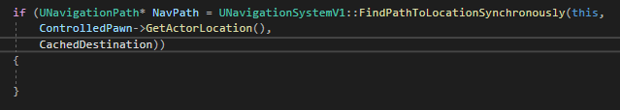

Now we have a path and the NavPath pointer should have PathPoints – a TArray of Vectors

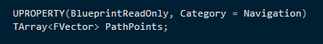

This is the path we are concerned with, starting at the controlled pawns location and ending at the destination

We’ll do this and add some debug spheres at the points so we can see what we’re working with

So, we’ll take the spline and first clear out any path points in it

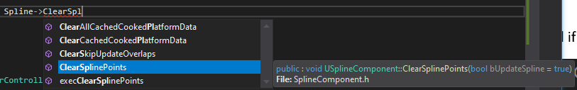 and then loop through the path

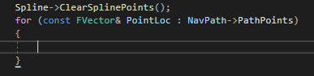

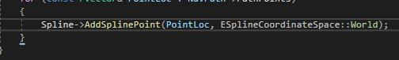

The Add takes a vector location so the ref for the points and a coordinate space, and World works fine here

So now we have added spline points to the spline and lets draw debug spheres

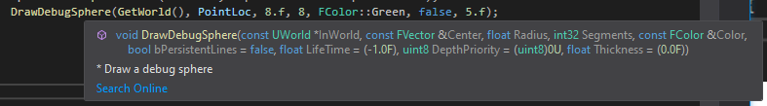

The Spline now has points so we will set Autorunning to True and since we are in released we are not holding the mouse button, so reset the FollowTime, and also reset Targeting to false

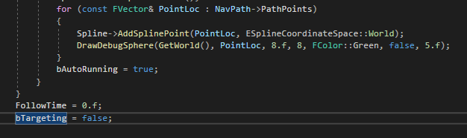

Autorun is not set for every point, just once, so it’s outside the for loop, and the 2 other vars are just inside the else because they are true whether we are going to run or not

Currently we are only populating the spline, not moving, but worth testing!

Oh no! Linker Error!



Makes sense though, because we are using the UNavigationSystemV1 – will require a module include in the build file

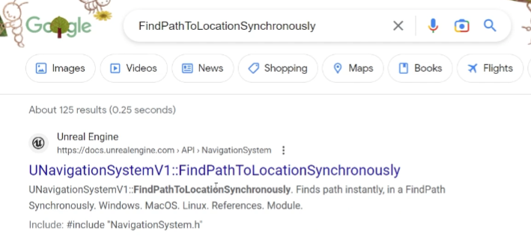

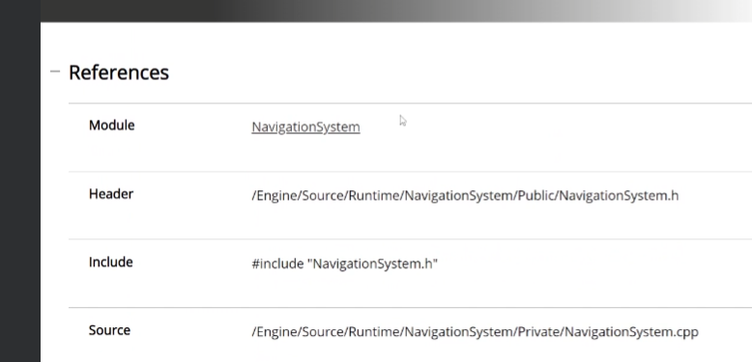

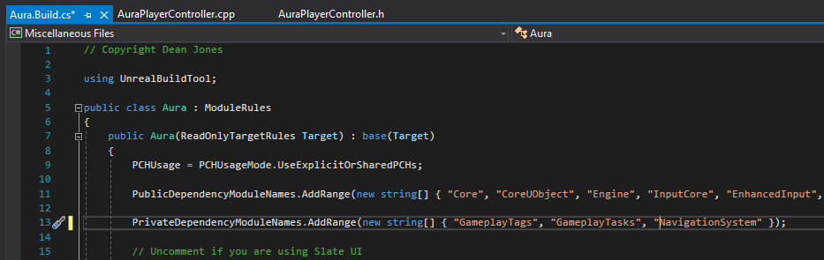

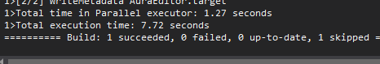

Now we are using the pathfinding algorithm pressing play and clicking does nothing; because no NavMesh Bounds Volume

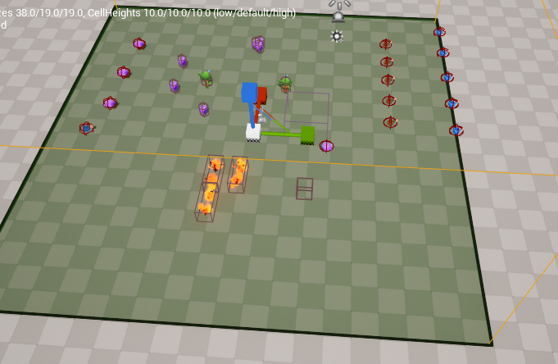

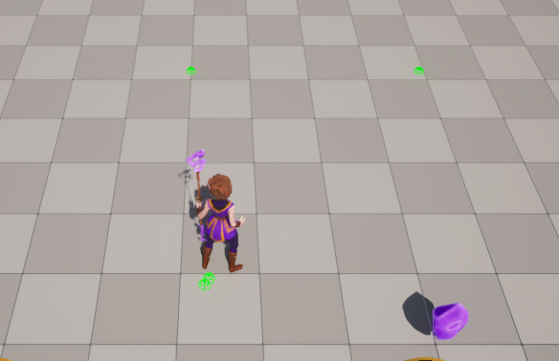

Straight line, boring, lets add obstacles!

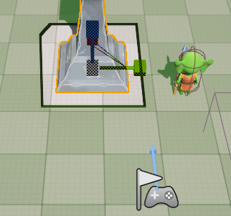

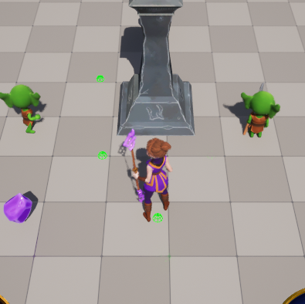

So a path IS being generated!

Now to Implement Autorun!

# Implementing AutoRun

AuroRun will operate per tick, so we will need to go to the Tick function next!

As a reminder, currently we inherit from PlayerTick and perform the cursortrace per tick

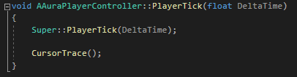

First we need the controller pawn, and we can put it into an if so that we only do this if there’s a valid pawn – in fact we could just check IsValid, which takes care of pendingkill.

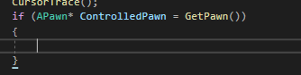

If we have a valid pawn, we also want the location on the spline that is closest to the valid pawn, because the pawn may not always be exactly on the spline

This would be an FVector

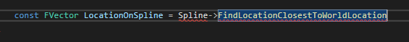

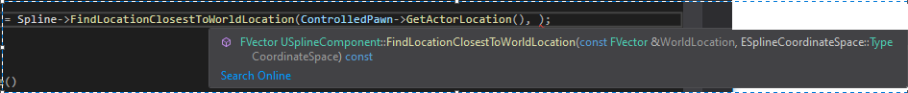

We pass in the actor world loc for the actor location and World in Spline Cordinate Space

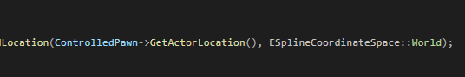

This vector is the location on the spline that is closest to the controlled pawn!

Now we have that, we can find the direction on the spline that corresponds to it by taking the Spline and calling another of it’s functions, FindDirectionClosestToWorldLocation



(actually the Pawn location would work fine for this in this particular case, but now we know a new function)

Once we have the direction, we know how to move the pawn

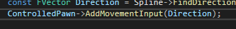

That’s it for movement; but we do also want to check distance to destination



And if it’s within the acceptance radius, stop moving.

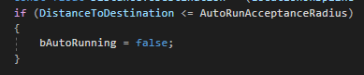

We can refactor this into it’s own function for autorunning and just call that in the tick function

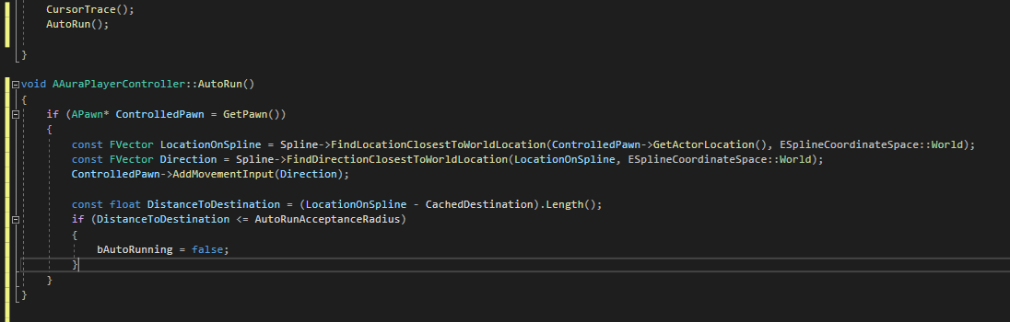

Time to test!

Hmm, the game starts with autorunning and when a click is made, this is cancelled

Clearly a bAutoRunning is not being set correctly somewhere?

Well, we’re calling AutoRun in Player tick, regardless of whether it SHOULD be called, or not!

Since we already have controls that will turn bAutoRunning on and off, we can just add a check to the start of the function

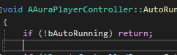

Adding this, it looks like Autorun works OK in 1P, and OK on the Multiplayer if we’re playing on the server but not a client

This is because in Project Settings we need to activate AllowClientSideNavigation in the project settings!

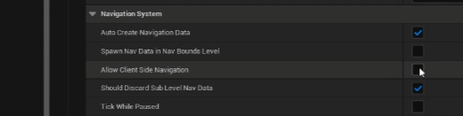

This solves the replication issue.

New Bug: if you click on something that does not implement the nav mesh but is inside it, like the pillar, the autorun engages and does not stop. How to solve?

Well, if we’re clicking on the pillar, obviously we want to move to the point behind it, as if it had not been hit, as if the cursor line trace didn’t see it

Simplest solution is to set the static mesh and disable the collision for the mesh so it ignores for visibility

Other potential issue:

Clicking on areas outside of the Nav mesh bounds volume, like the center of the gap caused by the pillar, we still have the same problem – the player runs to the end of the spline and does not stop because it’s not within the acceptable radius

Simplest solution is to take the last point in the spline and set that as the CachedDestination

Solution: in AbilityInputTagReleased, after looping through the PathPoints, set the CachedDestination equal to the Pathpoints Array indexed at Num – 1.

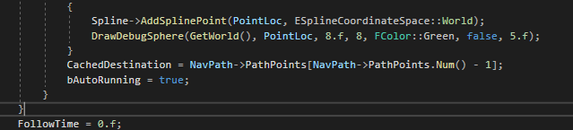

Now the acceptance radius is checked against the last point in the spline, which we know is reachable because it was generated

# Code Cleanup

Click to move now works, but let’s clean up the code a little before moving on

1. We’re getting the hit result under the cursor twice per frame and only need it once



Under AbilityHeld we get the hit result in the if; we also get it cursortrace

Since we are using it elsewhere in other functions, it makes sense to get it once and store it, We can then use it later on for other purposes

Moved from here 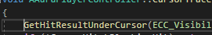to here in header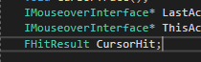

No other change needed, it’s now a member var rather than a local so it’s still scoped for CursorHit to use

And now AbilityHeld starts like this

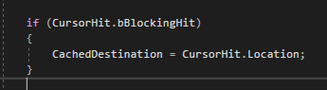

CursorTrace itself could be condensed = currently there are a lot of cases listed, but really we are only interested if ThisActor and Last Actor are not the same (case D)

So, we can start with “if (LastActor != ThisActor)”

Then, we already know the two are not the same and that LastActor is Valid, which means that we can unhighlight Last Actor, because ThisActor, whether it’s Null or not, is not Last Actor

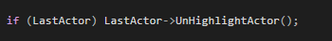

Similarly, if ThisActor is Valid, we know it’s not equal to Last Actor, we should highlight

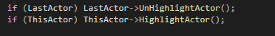

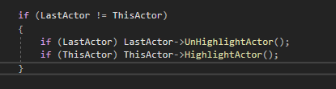

We can also do this:

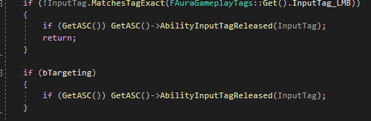

(although it’s not in line with the UE style guide)

Looks good, but one thing outstanding is that collecting a pickup item on the client does not show a notification message like on the server

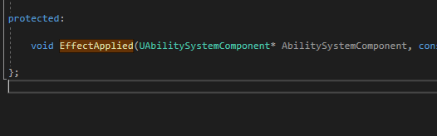

This is called here:

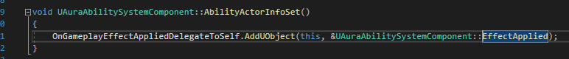

Looking at the declaration:



Called on SERVER when applied to self – this is why the callback never fires for the clients!

So how do we replicate this to the clients?

Not too hard

If we change the EffectApplied callback to an RPC – specifically a CLIENT RPC – it’ll be called on the server but also executed locally on the owning client

Give it this UFUNCTION

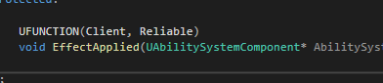

So it’s a client RPC and is reliable, that is it is guaranteed to reach the client even in the case of packet loss, it will keep sending until it’s verified received.

Convention says it should have Client in the name so

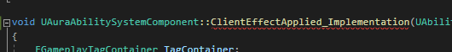

And called like this

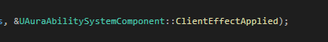

The HUD messages now replicate

# AuraProjectile

Time to create abilities that do stuff!

If you click somewhere you move to loc, but if you click on an enemy you activate an ability.

We want spells that do stuff!

Lets add a firebolt

We have an animation:

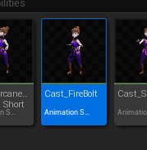

We need an effect

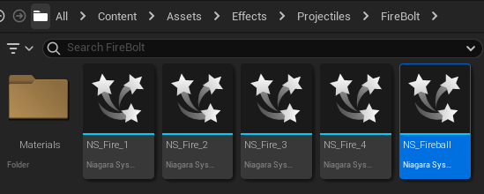

Since we are spawning projectiles we need a class of projectile to spawn!

It’s based on AActor

No plans to use Tick, so removing it and setting bCanEverTick to false

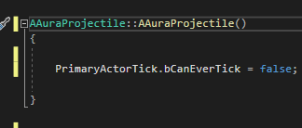

What do we want in this class?

* Hit Something
* Overlap Events
* In Effect actor we can add Overlap volume in BP and no need to access in C++ as long as we have a BP Callable function and pass in info like the Overlapped actor
* Or we could add in C++ if we know it’s always a sphere, use a sphere?

Addin the Overlap in code

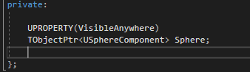

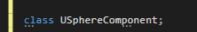

And a collision function:



Construction:

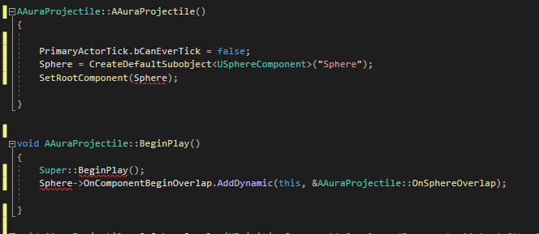

Nb Squiggles are because we need the include:

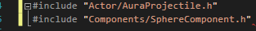

Set collision properties:

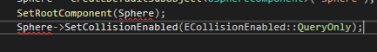

First ignore all channels default, then Overlap World Dynamic

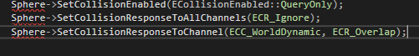

And then the same for Static and Pawn

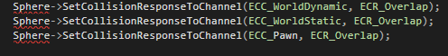

OK, now we have a sphere with an overlap callback. It’s a projectile, so it needs to move through the air:

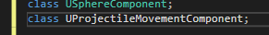

We might need to access this outside the class, so we’ll make it public

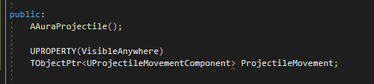

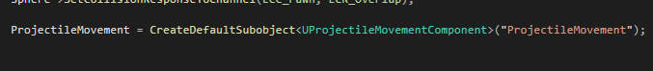

Create the Component and set the parameters (needs the include also)

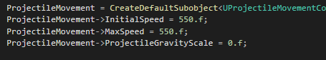

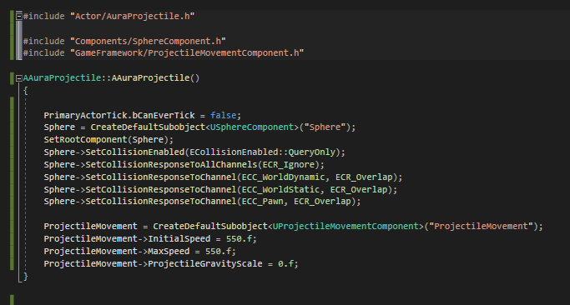

Skeleton is created, so now we can create the projectile in the editor:

We have the Projectile class, but we’ll make a specific Fireball class

It’s related to a gameplay ability so we’ll put it here in it’s own folder:



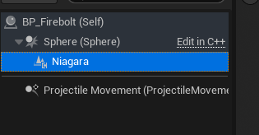

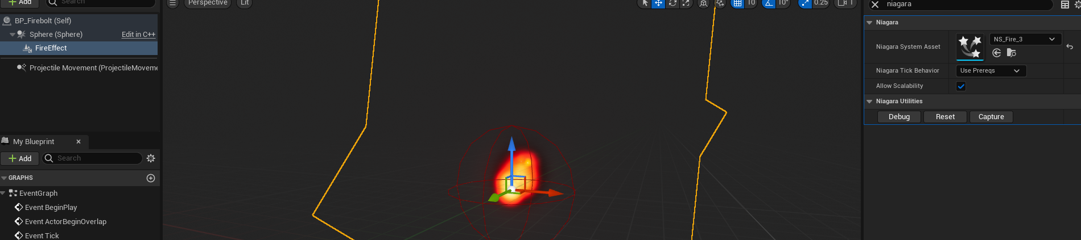

Now we have a firebolt, we can spawn then with an ability!